Voting Education Fast Facts
Voter education is training
Teaches voters with DD and Election Officials about voting.
        - Voters with DD become better voters
        - Election Officials put on better Elections
        - Voting tells our leaders what we think
Reaching voters is not easy
Knowing how different groups of voters with DD learn about voting and get information will help them:
  - Be up to date about how and when to register to vote
- Know where to vote
- Know important dates about voting
- Know what is on the ballot
- Know if any changes come up at the last minute
The survey results
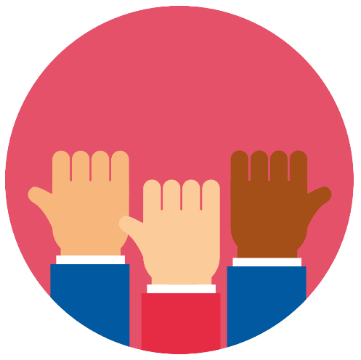
Tell us the kind of information voters with DD need to be good voters:
- Good Voters want to know their voting rights
- Good Voters agree to do their part and be a responsible voter
- Responsible Voters make sure they vote
Good Voters need information about voting, candidates, and issues

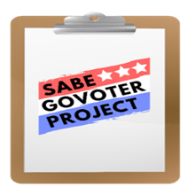
Voting Education and How Voters Get Information

Plain Language Summary:

Voting Education
  - Important information for Voters to know
  - How many days before an election do you register?
  - What date is Election Day?
  - What are the different ways voters can vote in their state?
Vote by mail includes both Absentee and Mail-in Voting
  - Does my state use Absentee and Mail-in Ballots?
  - What is the difference between the Absentee Ballot and the Mail-in Voting in my State?
  - How to get a Mail-in or Absentee ballot?
- How-to-answer Mail-in or Absentee ballots?
- What date must I mail my Ballot back to be counted?
Early Voting
    - What date does Early Voting start and end?
Vote at the Polls on Election Day
    - What date is Election Day?
    - Ask yourself, “Am I prepared to fill out my ballot”?
  - Any way you vote, you can use any of these ways to help solve your problems:
- County Board of Election
- Poll Worker
- P&A or Disability Rights Organization or Center
- Self Advocacy Groups and many others
Voting Education and How Voters Get Information
Plain Language Summary:
Voting Education Continued
  - Role of Poll Workers, how can they help?
- Show you where to sign in
- After you are done signing in Poll Workers will show you how to use the accessible voting machine
  - Where to find information on candidates and issues?
  - How-to-use voting equipment?
- Attend a training with voting equipment to practice with
- Watch videos on your local election website
  - Election Officials need to know about voters with DD:
- How to talk respectfully and clearly
- Ability to explain instructions in a way that all voters can understand
  - Make sure written information is easy to get, easy to see, easy to read and understand, easy to use by all voters
- Where to place, set-up, and know how to use the accessible voting machines
- Poll Workers need more training time to learn different ways to support voters with DD

Voting Education and How Voters Get Information
Plain Language Summary:
Voting Education Continued
- Where to find voter education information:
- The SABE GoVoter Project Vote Toolkit
- Your state P&A
- Your state Secretary of State Office
- Your local Board of Elections
- 5 of 10 voters in 2020 did not know who to call for help
- This means that only half of the voters knew who to call
- 8 of 10 First-time voters in 2020 knew who to call for help
- Few Voters of Color knew who to call for help when they vote:
- 1 of 10 African American or Black voters knew who to call for help
- 2 of 10 Native American voters knew who to call for help
- 4 of 10 Asian voters knew who to call for help
- 5 of 5 Latino voters knew who to call for help
- 6 of 10 Mixed race voters knew who to call for help

Voting Education and How Voters Get Information
Plain Language Summary:
Voting Education Continued
- The 2020 survey results tell us:
- Voters with DD go first to their local Board of Elections for help
- First-time voters go to their staff first for help
- The number one choice reported by all voters answering the survey was they went to their family for help
- When we know who voters go to for help. We can tell the people who support voters to be ready to help
- 4 of 10 voters went to their local Board of Elections for help

- 2 of 10 voters went to their state P&A

- 1 of 10 voters said they had a voting problem

- 4 of 10 voters with a voting problem reported it

- 6 of 10 of voters who reported problems felt their problem was solved

- Voters try to use national, state, and local Election websites to learn more about voting
- This is difficult because many do not own computers or have internet service

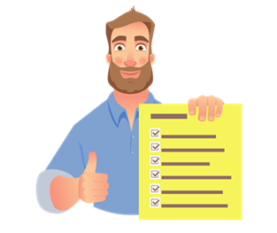
Voting Education and How Voters Get Information

Action Needed:

Voting Education
      - Meet with Election Officials, Self Advocacy and Vote Groups to talk about training topics voters with DD think are important for Election Officials to cover
- Brainstorm ways to make this happen
      - Offer the services of Self Advocacy Groups to provide the training for staff and Poll Workers
- Let them know the best way to learn about people with disabilities is from people with disabilities
- Come up with a plan to include people with disabilities in their trainings
      - Use voting education Fast Facts as a handout to leave with policymakers and legislators
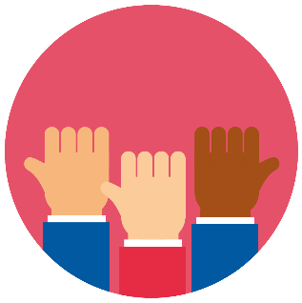
Fast Fact Voter Education Handout available on page 127 or can be printed from the govoter.org website
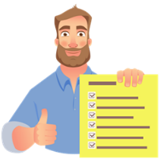
Voter Education and Ways to Get Information
Action Needed:
Voting Education Continued
How voters get information
- Host a meeting with Self Advocacy and Disability Vote Groups to review the kind of information voters with DD tell us they want to learn. Talk about ways to do this:
- Are there resources or information to help educate voters?
- Where can they go to learn about voting?
- Who to call if they have voting problems?
- What to do if their problem is not solved
- Work with Election Officials to get information out fast when there are changes or corrections to any part of the process
- Brainstorm ways to make voting better for voters with DD
Fast Fact Future Elections Handout available on page 124 or can be printed from the govoter.org website
Voter Education and Ways to Get Information
Action Needed:
Voting Education Continued
How voters get information
- Disability and vote groups need to look at why we are doing a better job of letting First-time voters know where they can get help. Then they can share this information with more voters

- Does my state use a Provisional Ballot?
- Provisional Ballot is when I am told I cannot vote for any reason or if they cannot find you on the register
  - It is best to ask them to show proof of why you cannot vote before filling out a Provisional Ballot
  - Ask how Provisional Ballots will be counted

