Update and Quarterly Report Summary:

State Name: NC People First of NC,Inc.



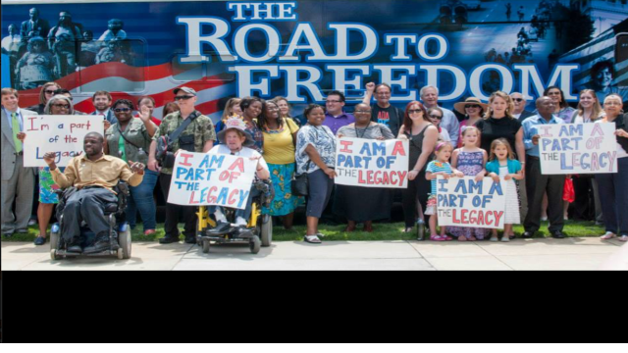 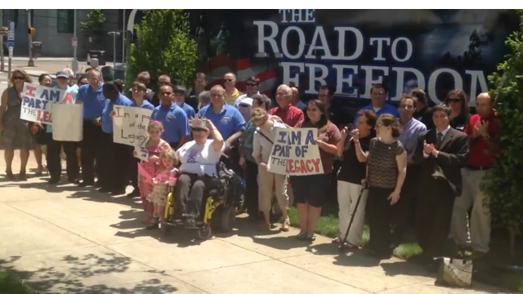 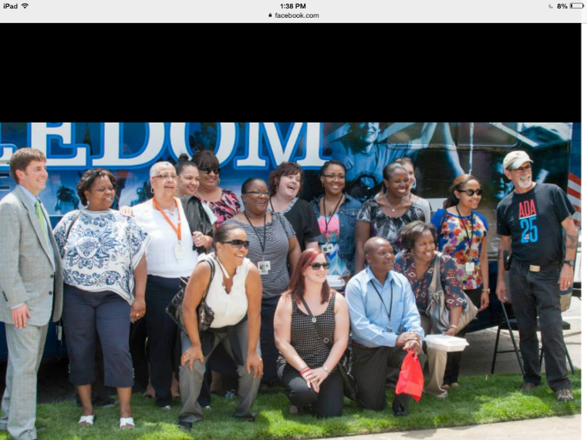 Partners ARC< DD COUNCIL< UCED UNC, Blind Assoc., Independent living, DHHS, Autism NC 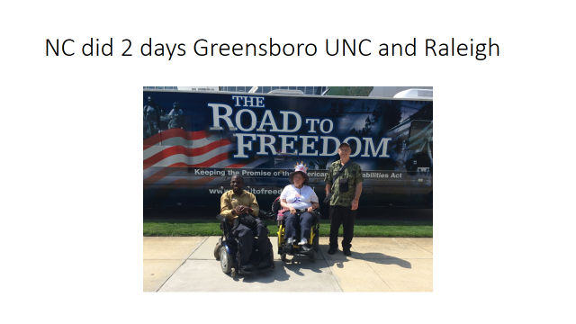and then did Charlotte as a partnership with DD Council

We gave out 250 cake mixes and Icing from Jiffy mix corporation 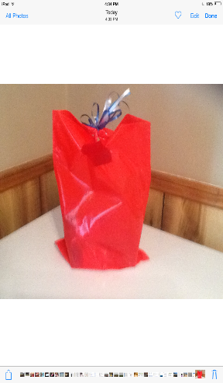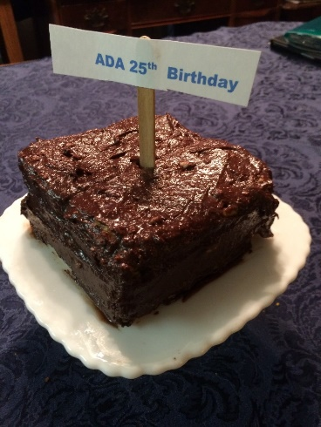

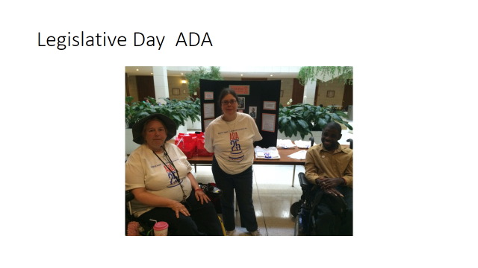

Accomplishments from Year One: (October 2013-September 2014)

__done__ Surveys Completed

_done___ Vlogs Produced

Topics of Vlogs: _Road to Work. ADA Door accessibility, ADA Parking __________________

________________________________

Who represented your state on the advisory committee and at the face to face advisory committee meetings?

Nashville __David and Ellen by face time_______________________

Birmingham ____David Ellen and ANNA___________________

Highlights from your state that you are proud of from Year One:

We are 501c3 non Profit, we have the ARC of NC and NCDD Council working with us and we have the Power of the Dream Inc.

We have gotten grants and are operating on our own.

We are meeting with partners ARC , DD Council , other disability groups, ADA Legacy tour, presenting on Employment with NC APSE, Did a conference and workshops and booth on People First of NC, held our FIRST legislative day as PF.

Talked to new folks about new groups and visited existing groups.

Report October, 2014- June, 2015:

Advisory Committee Meetings: List self advocates and others who attended these meetings;

Oklahoma City: _ellen and David___________________

_________________________________

Myrtle Beach: ____Ellen and David ANNA was on phone when it worked_________________

_________________________________

Allies, who participated in face to face meetings, supported your plan implementation and webinars:

_______ANNA NCDD Council and she represents Power of the Dream Inc. also ___ARC has been continued up dated on this info_______________________________________________________________________________________________

Webinars that you participated in this year: (Someone from your state was expected to participate in each webinar)

**February 18:** SALT: Leadership Skills: Number who participated: _3____

**April 23**: Strategies for Building an Effective Team

Number who participated: __2 David was in hospital Dr. care ___

**June 18**: Strategies for recruiting youth membership recruitment:

Number who participated: __3 by phone ___

**July 16:** Steps in organizing around an issue:

Number who participated: __2___

**August 16**: Partnerships outside of the disability community:

Number who participated: ___2__

**September tad**: Closing Institutions

**Local or state events**

October 2014-June 30, 2015 (8 grassroots events-2 per quarter)

Oct Employment Transition in high school, Nov. Transportation and ada parking at city councils,Jan worked on ADA grass roots to get people educated on ADA and 25 anniversary, Conference in March, April meetings on education on waviers and waviers changes, May Legacy tours, June partner working together to get the word out for self advocates and people to people project.

________________________________

Date Vlog submitted (2 needed for year) __this has already been done ___

Topic(s) of Vlog_ADA parking and door access_____________

Grants obtained with partners to work on priority issues. (Describe the grant and the partners)

Grant for $1000 to do conference and out reach (NASCAR friends )

Grant for $1500 in kind for ADA Legacy Tour and July 26th ADA party

500 cake mixes and icing Cake topper and etc.

Grant $500 brochures banners for all regions. SMI inc

Grant for T shirt sales ADA $500 Nascar Friends

Retreat with Partners: Date(s) Partners who participated

March 27 and 28

NC DD Council, ADA Network, ARC state and 3 local chapters,

Other state plan activities that you are proud of from 2015:

_We will give out the other 250 cakes at the Birthday bash for ADA July 26

________________________________________________________________________________________________________

_________________________________________________________________________________________________________

_________________________________________________________________________________________________________