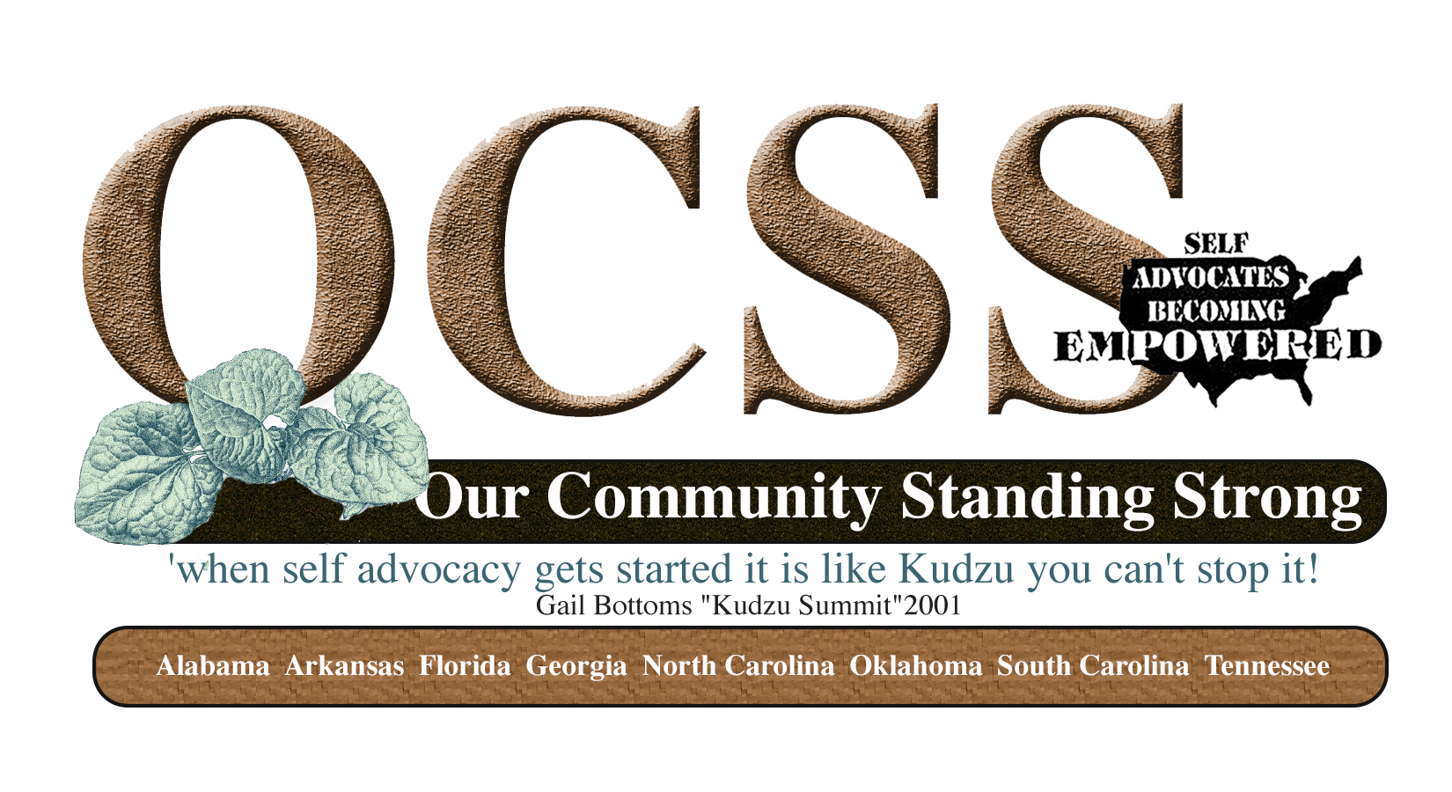
Minutes
State Call Tennessee
12/18/14
4:30 PM CST-5:30 PM EST
Paricipating: Bill Gage, April Meredith, Lori Mabry, Anna Bass, Jennifer Lauren Austin, Emma Shouse, Carol Rabideau, Chaqueta Stuckey, Glenda Hyman Singletary, Juliana Huerena, Vicki Hicks Turnage

- Review of Work Plan to assure inclusion of contract requirements
- Identification of two ways SABE and OCSS can support your plan activities
- Surveys- Evaluation and 2015 Plans
- Questions and Answers


State Technical Assistance Project Work Plan
Goal: Develop and Implement a State Technical Assistance Needs and Plan to strengthen the organization
Measurable Outcome(s): Participating State Self Advocacy Organizations develop, implement and monitor an individualized plan for strengthening their organizations and local groups capacity to run their organizations through partnerships with SABE, DD Network, and community organizations.
State Name: People First of Tennessee
Contractual requirements in red: Tennessee has addressed all of the required contractual areas.

Objective | Action Steps | 1*  October-December  2014 | 2*  January-March  2015 | 3*  April-June | 4*  July-September
To develop or enhance partnerships with DD Partners in your state | - Host a retreat to identify ways and timeframes on activities that you can work on together.  We realized that we could not do this in first quarter, hosted a regional meeting in the 1st quarter. We talked about our plan and how to build our chapters, we had 27 people sign up. We only had 3 people plus our planning group (10)  Ideas for more participation:  Using a phone tree  Creating an incentive  Creating a contest | Late Oct.  Retreat planning mtg. Aug. 12 or 13
Increase connections to the grassroots to promote self advocacy efforts | - Host five regional grassroots meetings with a partner to help recruit members and help old and new members develop a plan for starting local chapters in their region. We will host three grassroots meetings with a partner to focus on (1) Employment First and (2) building a stronger state organization.  Moving meetings around  Meet where people are locally or regionally  Meetings to recruit members  Meetings with partners for Employment First | (Retreat to plan regional visits in the next 3 quarters) | Middle TN (Nashville or Murfreesboro | East TN Knoxville  West TN (Jackson – Union College) | West TN (Memphis)  Upper East TN (ETSU)
Enhance the state leadership skills in providing peer to peer technical assistance in their state and the region | - Participate in Quarterly Advisory Committee meetings for OCSS.  - Attend face to face meetings and webinars.  - Present on at least one OCSS webinar. (Do you have any topics that you would like to present on?)  Will put on meeting agenda  - Submit at least 2 vlogs on issues of concern.  Including different disabilities ( people who have newly acquired a disability, people that have a disability) in the community (developing questions to address and prioritize) ex: putting on make-up  Youth  Send 1 of 3 ways to Vicki:  - May upload to YouTube & send link  - Send video file  - Use Drop box  - Participate in OCSS Webinar by reporting state experiences,  Participating in webinars and training | Oklahoma meetings  TBA  TBA after OKC mtg.  April & Jennifer  (Navigating Disabilities: Q&A - Part 1)  TBA | TBA  April & Jennifer  (Navigating Disabilities: Q&A - Part 2)  TBA | TBA  TBA | TBA  TBA
Establishment of state structure to maintain connections with grassroots | - Develop a strategic plan and funding (financial plan) for a state structure that supports grassroots issues.  - Secure at least one grant per year with the support of your partners.  Veterans with disabilities (under age 21)?  Transitional age youth (self advocacy and adulthood)  Add domestic violence grant, Julie Petty, Arkansas? | Investigate grant opportunities, write letters of intent, plan grant writing schedule:  Campaign for Human Dev.; Murfreesboro Community Development Block Grant; HUD Community Development Block Money | X


How can the OCSS Team or others on the Advisory Committee help you with your plan??? Identify two ways.
1.) Ideas about how to increase attendance and how to secure interest (follow-up about why they did not attend, was it transportation and funding for extra hour of additional supports, unfamiliarity of the event, test other days of the week and time of day)
2.) Ideas on how to get people to places of meetings, having access and how to use technology


Questions and Answers:
Please remember to complete surveys:
Year 1 evaluation 2014
Year 2 activities 2015

