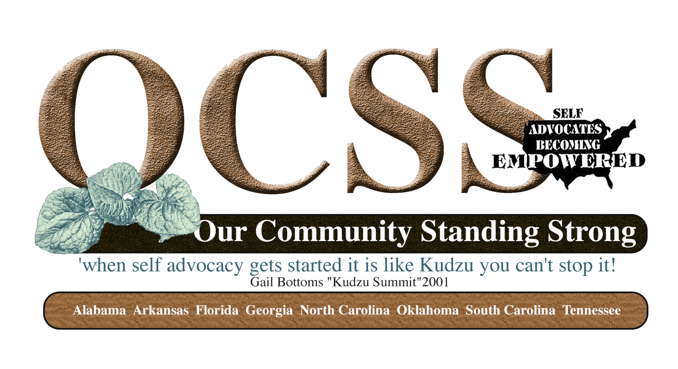
Minutes
State Call South Carolina
12/11/14
11:30 AM CST-12:30 PM EST
Participating: Impact South Carolina Board, Chaqueta Stuckey, Glenda Hyman Singletary, Juliana Huerena and Vicki Hicks Turnage

- Review of Work Plan to assure inclusion of contract requirements
- Identification of two ways SABE and OCSS can support your plan activities
- Surveys- Evaluation and 2015 Plans
- Questions and Answers


State Technical Assistance Project Work Plan
Goal: Develop and Implement a State Technical Assistance Needs and Plan to strengthen the organization
Measurable Outcome(s): Participating State Self Advocacy Organizations develop, implement and monitor an individualized plan for strengthening their organizations and local groups’ capacity to run their organizations through partnerships with SABE, DD Network, and community organizations.
State Name: South Carolina
Contractual requirements in red: South Carolina has addressed all of the required contractual areas:

Objective | Action Steps | 1*  October-December | 2*  January-March | 3*  April-June | 4*  July-September
To Develop or Enhance partnerships with DD Partners in your state | - Host a retreat to identify ways and timeframes on activities that you can work together on  - American Red Cross Volunteer Presentation  - Establish state conference  - Chat and Chew to discuss issues
Increase connections to the grassroots to promote self advocacy efforts | - Host 2 per quarter (8 for year) Grassroots Events with a partner to promote one or more of the issues identified in the needs assessment: Employment First/voting rights/human rights/self advocacy membership recruitment of Individuals with Disabilities, Olmstead, Marriage Penalty, Community Living, Transportation, Affordable Housing, relationships (what will be your issue(s)?)  What do you want to work on?  Transportation  Employment  Supportive Living  Relationships
Enhance the state leaderships skills in providing peer to peer technical assistance in their state and the region | - Participate in Quarterly Advisory Committee meetings for OCSS  - Attend Face to Face Meetings of the Webinar  - Present on at least one OCSS Webinar (what topic would you like to present)  Recruit Self advocates  Speak up for yourself  How to find transportation in your area  Beyond transportation  - Submit at least 2 blogs or Vlogs on issues of concern (what will be your topic?)  Transportation  Training and education, how to  How to educate  - Participate in OCSS Webinar
Establishment of state structure to maintain connections with grassroots | - Develop a strategic plan and funding (financial plan) for a state structure that supports grassroots issues  - Secure at least one grant per year with the support of your partners (what will be the purpose of your grant?)  The ARC  What will be the outcomes?  Health wellness and community participation  Where? 3 counties: Florence County (Walk this Way),  How many people?  By when?  - Complete 501(C)3 application

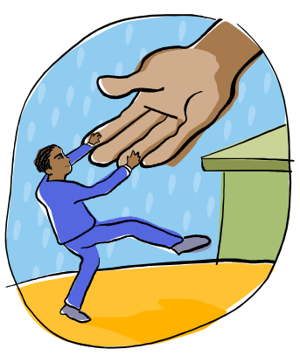
How can the OCSS Team or others on the Advisory Committee HELP you??? Identify two ways.
1.) training
2.) meeting conference with other states within the region
3.) help with specific issues such as: employment (work with groups of people)
4.) learn how to talk to people without getting mad at them, anger management


Questions and Answers:
Please remember to complete the following surveys:
Evaluation of year 1
2015 activities year 2

