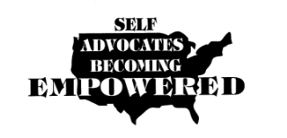



**Agenda**

**Our Community Standing Strong Advisory Committee Meeting**

**Date: May 8-10, 2014**

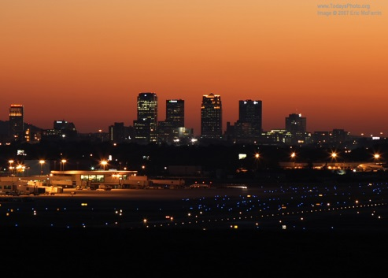

**Holiday Inn**

**492 Wildwood Circle North**

**Birmingham. Al. 35209**

**205-942-6070**

**Thursday May 8, 2014 Arrive at hotel**

**C:\Users\ADM01\AppData\Local\Microsoft\Windows\Temporary Internet Files\Content.IE5\3V8DWY9Z\MC900082831[1].wmfIf you are flying you will need to take a cab from the airport to the hotel as the hotel does not offer a shuttle service. You may call Yellow Cab at 205-222-2222. Yellow Cab also has an accessible shuttle. You will need to call 24 hours prior to your arrival time to schedule a pick up at the airport. If you use para-transit in your community you could also complete the necessary registration to request the use of this during your stay in Birmingham.** [**Http://www.bjcta.org/riding-on-max/paratransit/**](Http://www.bjcta.org/riding-on-max/paratransit/)

**As you know if you are arriving early or staying later than Friday evening you will need to pay for your hotel roo. The rate is $105.02 including tax. This includes Breakfast.**

[](http://whatscookingmexico.com/2008/08/22/multicolor-pasta-the-secret-is-in-the-sauc)

**Dinner will be on your own both evenings. We will have transportation to nearby restaurants. Restaurants are also within walking or rolling distance, if weather is good. Also, there is a restaurant on site.**

**Friday May 9, 2014**

**7:00 AM - 9:00 AM**

**Breakfast at hotel-included in room rate.**

**9:00 AM – 10:00 AM** 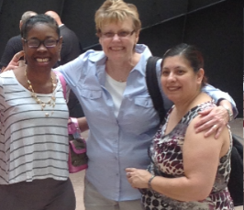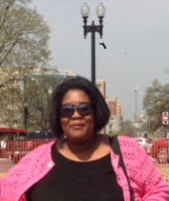

**Welcome**

**Updates on Project**

* **Survey status:**
  + **771 +**
  + **Finished NC and SC**
  + **AL-84 + = ?**
  + **AR-23**
  + **GA-123**
  + **OK-45 + 53 = 98**
  + **TN-45**
  + **FL-74**
* **Webinars and presenters**

|  |  |
| --- | --- |
| **Webinar dates** | **Topic** |
| **Thursday March 27, 2014** | Vogging: How to Vlog our message on issues |
| **Tuesday May 1, 2014** | Your State Plan Process |
| **Tuesday May 27, 2014** | Developing Strategies and Building Partnerships: How can our DD Partners help us? **TN, AL, Tia** |
| **Tuesday June 24, 2014** | Funding Strategies **???** |
| **Tuesday July 22, 2014** | Writing Grants **FL, OK** |
| **Tuesday August 26, 2014** | Keeping Grants **FL** |
| **Date to be determined** | How to Use Blogs **SC** |

* **State calls- The team will be scheduling state calls to discuss state specific issues over the next months.**
* **B(V)logs**
  + **5 States completed**
    - **AL**
    - **NC**
    - **SC**
    - **OK**
    - **TN**
* **Outcome payment to the states**
  + **Next Payment is planned for this month if surveys completed and B(V)log**
  + **Last Payment will be made when state have completed plan, hosted 2 grassroots events, submitted an update of progress and turned in last B(V)log**
  + **Next Year: 4 payments will be paid when states turn in quarterly reports showing completion of the activities**

**Chaqueta Stuckey, Julie Petty, Richard Chapman  
**

* **Developing a state technical assistance action plan**
* **Strategies for working with our Partners**

**Noon-1:00 PM [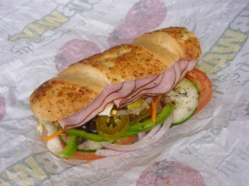](http://fr.wikipedia.org/wiki/Fichier:Subway_6-inch_Ham_Submarine_Sandwich.j)**

**Lunch and Networking**

**1:00 PM - 2:30 PM  
**

**State Teams work on action plans**

**2:30-2:45[](http://www.fotosearch.com/clip-art/break-time.ht)**

**Break**

**2:45-3:30   
**

**States presentations on Plans**

**3:30-4:30   
**

**Discussion of Action Items:**

* **Finalize selection of Logo**
* **Next Advisory Meeting: Oklahoma with National Conference: October 9-12, 2014**
  + **Should we include registrations for conference in budget**
* **Presentation on OCSS at National Conference in Oklahoma**
* **How to involve other Southern States in OCSS: Mississippi, Kentucky, Texas, Louisiana**

**4:30-5:00**

**Wrap Up**

**Plans for Civil Rights Museum and Disability History Exhibit**

**Saturday May 10, 2014**

**7:00 AM -9:00 AM**

**Breakfast and check out of your rooms if you are leaving on Saturday.**

**9:15 AM C:\Users\ADM01\AppData\Local\Microsoft\Windows\Temporary Internet Files\Content.IE5\943LKUJ8\MC900326644[1].wmf**

**Meet in Lobby for transportation to the Birmingham Civil Rights Museum and the Disability Rights Center.**

**If you drive to Birmingham, you will need to drive your vehicle to the Civil Rights Institute. It is only about 6 miles from the hotel.**

**We will have transportation for people who fly or come by train or bus. Accessible transportation will also be available for those of you who do not drive your own vehicle.**

**10:00 AM -11:30 AM **

**Birmingham Civil Rights Institute**

**11:30 AM - 1:00 PM**

[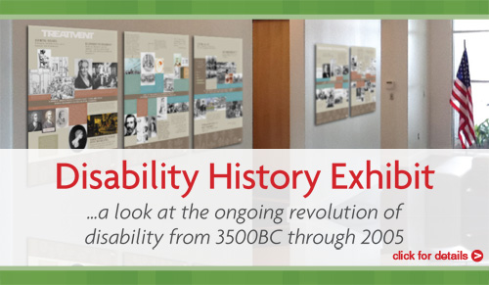](http://drradvocates.org/disability-history-exhibit/)

**Disability Rights Exhibit-Disability Rights and Resource Center**

** Lunch will be served at the Disability Rights and Resource Center**