Update and Quarterly Report Summary
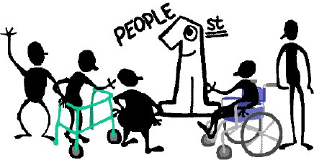
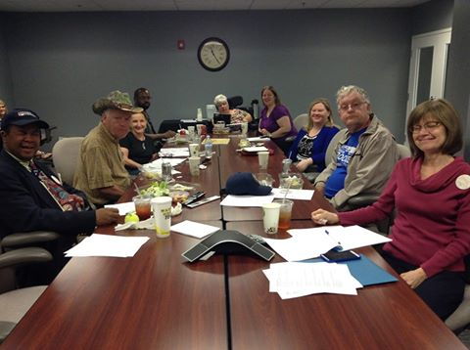
Accomplishments from Year One: (October 2013-September 2014)
150 Surveys Completed
2 Vlogs Produced
Topics of Vlogs:
- Basics of Self—Advocacy and the Importance of Speaking Up for Oneself (Gatha Logan)
- Closing TN’s Institutions (Bill Gage)

Who represented your state on the advisory committee and at the face to face advisory committee meetings?
Nashville Carol Rabido (VKC) and Emma Shous (TN Council on DD), Ruthie Beckwith, Bill Gage, Sam Gage, Gatha Logan
Birmingham Carol Rabido (VKC) and Anna Base (DRT), Bill Gage, Sam Gage

Highlights from your state that you are proud of from Year One:
- Successfully closed the last major institution in TN
- Created Facebook page and gained 155 likes as of July7 2015
- Gained membership

Report October, 2014- June, 2015:
Advisory Committee Meetings: List self advocates and others who attended these meetings;
Oklahoma City: Carol Rabido (VKC), Emma Shous (TN Council on DD), Bill Gage, Sam Gage
Myrtle Beach: Bill Gage, Sam Gage
Allies, who participated in face to face meetings, supported your plan implementation and webinars:
- Vanderbilt Kennedy Center
- TN Council on Developmental Disabilities
- Disability Rights of TN

Webinars that you participated in this year: (Someone from your state was expected to participate in each webinar)
February 18: SALT: Leadership Skills: Number who participated: 1
April 23: Strategies for Building an Effective Team:
Number who participated: 1
June 18: Strategies for recruiting youth membership recruitment:
Number who participated: 4
July 16: Steps in organizing around an issue:
Number who participated: _____
August 16: Partnerships outside of the disability community:
Number who participated: _____
September tad: Closing Institutions

Local or state events
October 2014-June 30, 2015 (8 grassroots events-2 per quarter)
01/2/15 Board meeting
01/15/15 National SABE Webinar
02/5/15 OCSS meeting with TN Partners
3/19 & 20/`15 Bill & Sam went to OCSS/Southern Collaborative Mtg
04/23/15 OCSS webinar
05/13/15 Conference call to prepare for MegaConference
05/22/15 Lorri, Gatha and Anna Mega Conference Presentation
06/03/15 Outreach to Nashville CIL for chapter sponsorship
06/04/15 OCSS meeting with TN partners plus Board meeting
06/11/15 Offered official support to NFB State Legislative Committee on issue of eliminating sub-minimum wages (offer accepted)
06/24/15 Lorri, Bill, Sam Cloverbottom court appearance
06-30-15 Go to TN State Meeting with OCSS/SABE

Date Vlog submitted (2 needed for year)
2 Vlogs: Completed on March 18, 2015. Submitted on March 19, 2015.
Topic(s) of Vlog
- Navigating Disabilities: Q & A Part 1 (April Meredith and Alicia Searcy)
- Navigating Disabilities: Q & A Part 2 (April Meredith and Alicia Searcy)

Grants obtained with partners to work on priority issues. (Describe the grant and the partners)
The Vanderbilt Kennedy Center, TN Council on DD, and DRT all help PFT financially by providing the following to us free of charge:
- Copies
- Pens and pads of paper at recruitment/info meetings
- Meeting rooms (DRT – Nashville and hotel conference room at Mega Conference)
- Candies and drinks at meetings
- Prizes to award at recruitment meetings

Retreat with Partners: Date(s) Partners who participated

Other state plan activities that you are proud of from 2015:
- Social Media – April Meredith and community partner Emma Shous has worked hard at setting up and regularly posting on the People First of TN Facebook page. Alicia Searcy has set up various social media pages for the up and coming Nashville PF chapter which is being spearheaded by Lorri Mabry and sponsored by the local Center for Independent Living.
- PFT has begun collaboration with another self-advocacy organization (National Federation of the Blind) to address the issue of sub-minimum wages for people with disabilities.
- PFT members have continued to be involved in seeing through the proper legal proceedings in closing all major institutions in TN.

