**SEMI-ANNUAL REPORT COVER SHEET**

|  |  |  |
| --- | --- | --- |
| 1 | **Grant Number** | 90DN0301-02-00 |
| 2 | **Project Title** | “Our Community Standing Strong” (OCSS)  A Regional Technical Assistance Center for the Southern Collaborative |
| 3 | **Grantee Name & Address** | 4401 West Northwood Lake Dr.  Northport, Al. 35473 |
| 4 | **Telephone number** | 205-310-4839 |
| 5 | **Project Period** | October 1, 2014-September 30, 2015 |
| 6 | **Reporting Period** | October 1, 2014- March 30, 2015 |
| 7 | **Project Director/Principal Investigator** | Vicki Hicks Turnage |
| 8 | **Report Author** | Chaqueta Stuckey  Vicki Hicks Turnage |
| 9 | **Telephone** | Chaqueta Stuckey: 843-319-0118  Vicki Hicks Turnage: 205-310-4839 |
| 10 | **Date of Report** | March 22, 2014 |
| 11 | **ACL Program Officer** | Katherine Cargill-Willis |
| 12 | **ACL Grants Specialist** | LaDeva Harris |

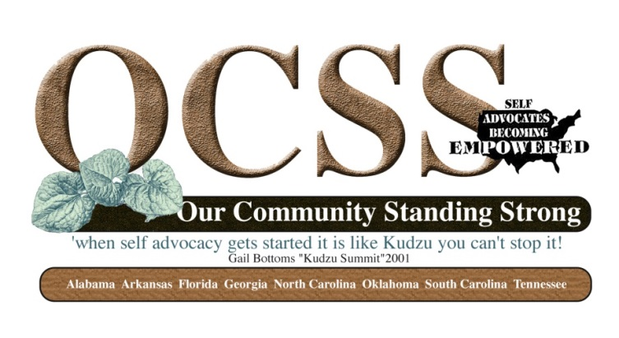

**SECTION 1**

|  |  |
| --- | --- |
| **Goal 1**    To provide regional technical assistance to strengthen the participating states capacity to increase and support self advocacy through relationships and partnerships at the community level. | |
| Objectives  C:\Documents and Settings\Katherine.CargillWi\Local Settings\Temporary Internet Files\Content.IE5\HYWMHL8B\MM900234700[1].gif | * 1. Identify capacity of SABE and participating states to provide peer advocacy and mentoring.   2. SABE and participating states identify resources and provide opportunities for training and leadership development for and by participating states.   3. SABE supports states in providing education and outreach to their local groups and community. |
| Activities  C:\Documents and Settings\Katherine.CargillWi\Local Settings\Temporary Internet Files\Content.IE5\UOH8537N\MC900440201[1].wmf | * As of March 31, 2015, seven of eight states have completed their state plans and are reporting progress.. Current count for submitted surveys is 1303. * We have collaborated with the Southwest Alliance Self Advocacy TA Center and they are using the survey developed during the first year of the project. This Center has completed 536. * <https://www.surveymonkey.com/results/SM-KYNYNS67/> * The Advisory Committee has met by Go To Meeting on November 19, 2014, January 1, 2015. * Met with 6 of 8 states by Go To Meeting to review their plans and accomplishments * Two Face to Face Meetings were held. October 11, 2014-Oklahoma City, Oklahoma (SABE National Conference) and March 19-20, 2015 in Myrtle Beach, South Carolina) * Webinars for period included:: SALT: Leadership Skills- Presented by People First of Oklahoma * Produced three Vlogs during the period: * Topics of Vlogs included: National Conference Experience, Medicaid, Accessibility and Celebration of Life for Jeff Ridgeway * We have posted the majority of our work on sabeusa.org. Our Community Standing Strong page * Posted events on SABE Facebook page * Continued to consult with Project Vote and ADAP on the screen reader version of Technology Handbook * Developed evaluation survey-Overall group satisfied with first year. * Link to Evaluation Results: 16 respondents * <https://www.surveymonkey.com/results/SM-8RRZGS67/> * Developed survey to narrow priority for 2015: 12 respondents * Link to Survey for Priority for 2015 * <https://www.surveymonkey.com/results/SM-RHS5PS67/> * Advisory Committee has reached out to Mississippi and   Virgin Islands we are in process of following up . |
| Outcomes  C:\Documents and Settings\Katherine.CargillWi\Local Settings\Temporary Internet Files\Content.IE5\1DMY56TI\MC910217623[1].wmf | 1. Advisory Committee met 4 times during period. ( 2 Face to Face, 2 Go To Meeting) 2. Open demographic survey and needs assessment surveys up to other states. 3. Peer to Peer Technical Assistance have been provided by representatives from all state organizations and their allies in advisory meetings, state team meetings, and webinars. 4. Our Community Standing Strong page on SABE website has been updated 5. 7 of 8 states have completed their plans and are in process of implementation. 6. Representatives for 7 of 8 states participated in webinar presented by People First of Oklahoma on their Leadership Training-SALT. 7. Four Vlogs (26 to date) produced during period. See Self Advocates Becoming Empowered Station-Our Community Standing Strong Video Series: <https://www.youtube.com/playlist?list=PLHe4SX3HJvyt8jUw4e5BzvfquH-2M1rXg> 8. Face To Face Advisory Meeting in Myrtle Beach focused on sustainability 9. Evaluation results indicated that we needed to continue work on using technology and teaching others how to use. The results indicated that Face to Face Contact and work with our partners was the most useful during the first year. 10. 2015 Plan Survey assisted us in identifying our Webinar and Discussion Topics for Face to Face meetings: This included: Technology, How to keep our efforts going (Sustainability), How to build effective teams, how to recruit new members and how to get members to work on issues. 11. The 2015 Plan survey identified to Regional Projects that states could work on together (Long Home Road and ADA Events). |

**SECTION 2:**

**Collaborations**

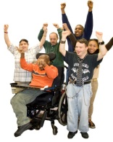

1. Met by conference call with AIDD and other SA Regional Technical Assistance projects on
2. NEAT and OCSS presented a presentation for the National Conference in Oklahoma City on Vlogging
3. Continued collaboration with the Southwest Alliance and Heartland Centers on Self Advocacy
4. Continued efforts with Project Vote and Alabama Disabilities Advocacy Program in the production of a screen reader accessible version of the Technology Handbook.
5. Collaborated with states on their plan implementation
6. Continued to encourage partner participation in advisory committee meetings and webinars.
7. Partners from UCEDD’s (Vanderbilt University, University of South Carolina, and University of Arkansas), Tennessee DD Council, P and A’s from Tennessee, Alabama and Arkansas have been active participants in webinars and advisory committee meetings.

**SECTION 3**

**Problems**

1. One state self advocacy group continues to have problems with survey completion and plan development. Our team is working with this state and there partners. Two of their DD Partners attended the Face To Face Advisory Committee meeting in Myrtle beach
2. We continue to struggle with technology and access for committee members , but we have the attitude that we have to continue to try to experiment with technology to assist people in becoming more comfortable with technology as a means of strengthening our efforts.

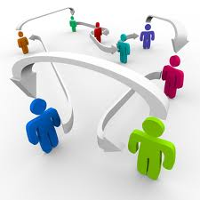**SECTION 4**

**PRODUCTS THAT HAVE BEEN DISSIMINATED**

**IN THE LAST SIX MONTHS**

1. Financial report for quarter
2. Webinars : SALT Training
3. State Plans
4. SABE Nation featured article in Fall Newsletter, NEAT Newsletter, and Spring Newsletter (to be released at the Disability Policy Summit)
5. 3 Vlogs posted on you tube.
6. Assisted in production of Screen Reader Version Technology Handbook Publication.
7. Presentation on Vlogging at National Conference
8. Sustainability Workshop at Face to Face Advisory Meeting
9. Overview of Project and Accomplishments- Presented at Face to Face Advisory Meeting
10. State team Plan review Go To Meeting
11. Advisory Committee Meetings Minutes -Go To Meeting
12. Evaluation 2014 and Plans for 2015 Survey-Survey Monkey
13. Technology Handbook –Project Vote and OCSS