**QUARTERLY REPORT COVER SHEET**

|  |  |  |
| --- | --- | --- |
| 1 | **Grant Number** | 90DN0331-01-00 |
| 2 | **Project Title** | “Our Community Standing Strong” (OCSS)  A Regional Technical Assistance Center for the Southern Collaborative |
| 3 | **Grantee Name & Address** | 4401 West Northwood Lake Dr.  Northport, Al. 35473 |
| 4 | **Telephone number** | 205-310-4839 |
| 5 | **Project Period** | October 1, 2013-September 30, 2014 |
| 6 | **Reporting Period** | July 1, 2014- October 31, 2014 |
| 7 | **Project Director/Principal Investigator** | Vicki Hicks Turnage |
| 8 | **Report Author** | Chaqueta Stuckey  Vicki Hicks Turnage |
| 9 | **Telephone** | Chaqueta Stuckey: 843-319-0118  Vicki Hicks Turnage: 205-310-4839 |
| 10 | **Date of Report** | October 27, 2014 |
| 11 | **ACL Program Officer** | Katherine Cargill-Willis |
| 12 | **ACL Grants Specialist** | LaDeva Harris |

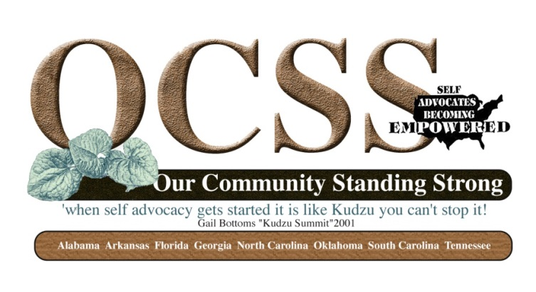

**SECTION 1**

|  |  |
| --- | --- |
| **Goal 1**    To provide regional technical assistance to strengthen the participating states capacity to increase and support self advocacy through relationships and partnerships at the community level. | |
| Objectives  C:\Documents and Settings\Katherine.CargillWi\Local Settings\Temporary Internet Files\Content.IE5\HYWMHL8B\MM900234700[1].gif | * 1. Identify capacity of SABE and participating states to provide peer advocacy and mentoring.   2. SABE and participating states identify resources and provide opportunities for training and leadership development for and by participating states.   3. SABE supports states in providing education and outreach to their local groups and community. |
| Activities  C:\Documents and Settings\Katherine.CargillWi\Local Settings\Temporary Internet Files\Content.IE5\UOH8537N\MC900440201[1].wmf | * The Alabama Developmental Disability Council and People First of Alabama invited the Executive Committee of SABE and three members of the OCSS Advisory Committee to provide Technical Assistance for the Alabama Partners and members of the Board of People First of Alabama. In addition, members of the project and SABE Executive Committee presented workshops at the People First of Alabama Annual Conference. 45 people participated in the Technical Assistance event. 100 people attended the People First conference. Attached is the report for the Technical Assistance. Dates of the event were August 19-22, 2014 * As of June 30, 2014, seven of eight states have completed their surveys. Current count for submitted surveys is 1295. We are still working with Arkansas to complete. We have also consulted with two applicants for SA TA funding regarding the possibility of expanding the survey to the states they have targeted. * Committees and Advisory Committee met via GoToMeetings and Webinars There were an average of 14 participants for Advisory Meetings. * Webinars for quarter included: * July 1, 2014 Funding Strategies: Presented by all states and OCSS * July 22: Writing Grants: Florida and OCSS State Team Members * August 26 Keeping Granting: Florida and OCSS State Team Members * Blogging webinar was postponed, but a video blog was produced by South Carolina that will be posted to You Tube * All eight states have completed at least one video blog. The project has produced 21 Video Blogs and 2 Blogs during the First year of project.   1. Topics of Vlogs were: Introduction to the OCSS project, employment, children in nursing homes, working with legislators and policy makers, closing institutions. * We have started to post our work on sabeusa.org=Our community Standing Strong page * Posted events on SABE Facebook page * Two Advisory Committee members, Richard Chapman-FL and Eric Treat-AR assisted Project Vote and SABE in producing the Technology Handbook. Vicki Hicks Turnage assisted with editing and Robin Lunceford, Alabama Disabilities Advocacy Program acted as publisher for the Handbook. * Due to illness Chaqueta Stuckey was not able to present at the Reinventing Quality Conference, however Glenda Singletary and Julie Petty facilitated a discussion with Katherine Cargill Willis and others at the conference. |
| Outcomes  C:\Documents and Settings\Katherine.CargillWi\Local Settings\Temporary Internet Files\Content.IE5\1DMY56TI\MC910217623[1].wmf | 1. Advisory Committee has met by Webinars 3 times during quarter. In addition, three members of the Advisory Council along with the SABE Executive Committee and Project Staff provided Technical Assistance to Alabama. The next Advisory meeting will be held at the National Self Advocacy Conference in Oklahoma City October 9-12, 2014. All states will be in attendance. 2. 1295 needs assessments collected as of June 30, 2014. Only one state did not complete their surveys. Survey Goal: 1200 <https://www.surveymonkey.com/results/SM-33MJSKT/> 3. Peer to Peer Technical Assistance have been provided by representatives from all state organizations and their allies through webinars and a TA Meeting with People First of Alabama and allies, 4. Our Community Standing Strong page on the SABE website has been launched. 5. 7 of 8 states have completed their plans and are in process of implementation. 6. States also participated in the Webinars on developing their state plan, how can our DD Partners Help Us: Strategies for Building Partnerships? Funding Strategies, How to write and keep grants. For the year the project conducted 9 Webinars. There were an a 7. Produced 21 Vlogs and 2 Blogs   <http://www.youtube.com/playlist?list=PLHe4SX3HJvyt8jUw4e5BzvfquH-2M1rXg> |

**SECTION 2:**

**Collaborations**



1. ASAN and NEAT met by conference call with AIDD on September 16, 2014.
2. NEAT and OCSS planned a presentation for the National Conference in Oklahoma City on Vlogging
3. Collaborated with two new applicants for Regional Self Advocacy Technical Assistance Centers
4. Members of OCSS Advisory Council, staff and a staff member of Alabama Disabilities Advocacy Program assisted in the production of a Technology Handbook.
5. In addition, the Alabama DD Council invited members of the OCSS Advisory Committee and the SABE Executive Committee back to Alabama to provide Technical Assistance to People First and the DD Partners. This is scheduled for August 19-22 in Birmingham. The attendees conducted workshops, Keynotes and participating on panels at the People First of Alabama conference on August 21-22.
6. Sibling Leadership Network continues to be supportive.

**SECTION 3**

**Problems**

1. SABE Website is in process of reconstruction so the project has been delayed in establishing a page for Our Community Standing Strong. We have made progress but still have a great deal of work to do to complete posting of all activities.
2. One state self advocacy group continues to have problems with survey completion and plan development. Our team is working with this state and there partners.
3. Internal communication and interactions within state organizations continue to present a problem in one state.

**SECTION 4**

**PRODUCTS THAT HAVE BEEN DISSIMINATED**

**IN THE LAST THREE MONTHS**

1. Financial report for quarter
2. Technical Assistance Report for Alabama
3. Webinars are ready to be posted on website
4. State Technical Assistance Plans
5. PowerPoint presentation on Funding Strategies, How to write and keep grants.
6. Individual State Demographic Surveys/Initial Technical Assistance Plan
7. SABE Nation to be released at National Conference will feature articles from OCSS and states in the project.
8. 21 Vlogs posted on you tube.
9. Assisted in Technology Handbook Publication funded by AIDD

**Technical Assistance Event in Alabama August 20-22, 2014**

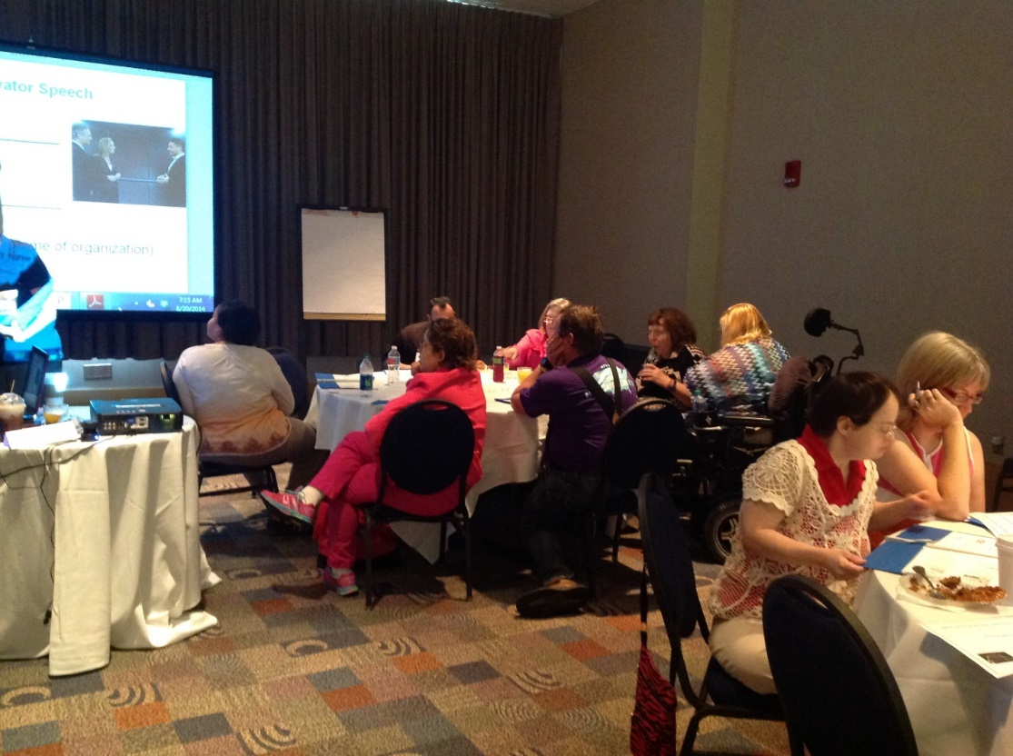

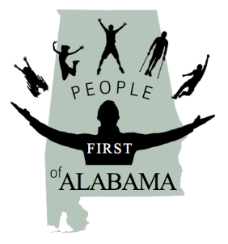 August 20, 2014

“It Takes a Village

“People First of Alabama and Ally Retreat with SABE and OCSS leaders to develop strategies to strengthen self-advocacy in Alabama

Participating: See attached list of participants

Facilitation: SABE: Nikki Dawson, Chaqueta Stuckey, Teresa Moore, Juliana Huerena, Vicki Hicks Turnage

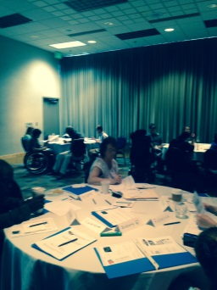

**Brainstorming Session on Membership recruitment with emphasize on youth issues was held. Ideas generated included:**

1. Youth Summits
2. Focus on Bullying issues
3. Reach out to transition age youth though schools-Junior people First Groups in high schools and middle schools
4. Partner with SABE on project vote and reach out to youth and young adults
5. Participate in transition conferences and fairs
6. Identify youth mentors
7. Invite youth to local People First meetings
8. Talk about employment with youth
9. Reach out to college students with and without disabilities
10. Educate youth and others about diversity issues, hurtful language (“R: word”), how to be a community activist, self-advocacy, how to organize around issues, strategies to get your message out
11. Know how to communicate your message about self-advocacy
12. Talk about supported decision making
13. Talk about disability history, ADA, pride,
14. Youth and Seasoned leakers work together
15. Educate youth about how our past and be our future is we do not continue to work on our issues.
16. Develop classes/education/ on self-advocacy and how to organize around issues and make a difference
17. Challenge youth to make a difference in their communities
18. Mix it up –Business and Fun at your meetings and events- go out for lunch, go to movies, extend personal invitations to youth
19. Embrace youth cultural-know who they are and their interests
20. Collaborative with other cross disability efforts, parents and sibling organizations, (Arc, Sibling Network, Family Ties and Downs Syndrome Organization)
21. Pick a couple of human rights issues of importance to youth and organize actions in their local communities
22. Reach out too Youth at Risk on bullying and labeling issues

C:\Users\ADM01\AppData\Local\Microsoft\Windows\Temporary Internet Files\Content.IE5\FUE1ZU4H\MC900056986[1].wmf**Next steps:**

1. People First, SABE and OCSS leaders will excite people who attend the conference about employment and power of self-advocacy
2. SABE will compile the list of ideas and what we said we would do.
3. People First and ADAP will plan an employment First Retreat
4. People First-YEL will conduct a Youth Summit focusing on Project Search Participants
5. Assign People to the activities listed below

**What activities can People First, SABE, and Partners and Allies do to begin to take action?**

People First and YEL

1. Use training material available from Green Mountain Self Advocates, SABE, Advocating Change Together, Yakit and other groups to develop and provide leadership training around self-advocacy, organizing around issues/how to become a community activist around employment, bullying and human rights at regional level.
2. Host a Youth Summit
3. Work with partners to develop an employment First campaign
4. Develop a clear message and teach leaders how to communicate it
5. Review and evaluate current status of strategic plan, focus on employment, increasing youth involvement, and voting
6. RALLY MEMBERS AROUND EMPLOYMENT

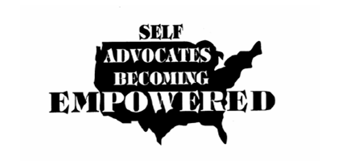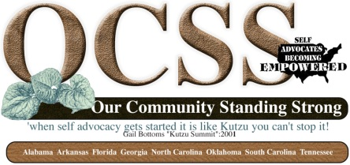

1. Develop agreement with ADAP for Project Vote
2. Continue technical assistance from OCSS with mini grants for next two years for People First to work on these issues
3. Prepare minutes of brainstorming session and actions identified

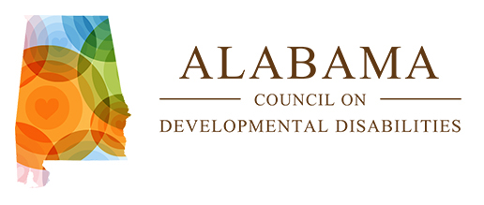

1. Continue to Fund YEL
2. Look at possibility of funding employment campaign
3. Add emphasize in Project Search Project on self-advocacy leadership skills
4. Employ a person(s) with intellectual disability with the Council
5. Continue to participate in planning sessions with People First around employment and youth issues
6. Continue to support People First Conferences and National Conference attendance

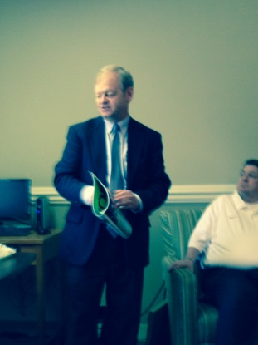

ADAP

1. Participate in planning with People First around employment and other issue
2. Serve on Advisory Board
3. Assist with organizing and presenting with People First at Grassroots events
4. Participate in Project Vote and OCSS project with SABE
5. Consider hiring a person with an intellectual disabilities at ADAP

UAB

1. Participate on Advisory Committee for People First and SABE OCSS
2. Explore student internships with People First through LENDS
3. Consider supporting youth chapter
4. Assist with Data Analysis for OCSS from survey
5. Consider development of supports needed to include a self-advocate in the LENDS program
6. Consider a self-advocacy/disability rights class for LENDS interns

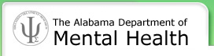 DMH

1. Participate on Advisory committees for SABE and OCSS
2. Continue funding for People First
3. Collaborate on Employment First Campaign
4. Consider hiring a self-advocate at each regional office to work with regions to support chapter development and youth issues
5. Add self-advocacy leadership as a focus for Project Search

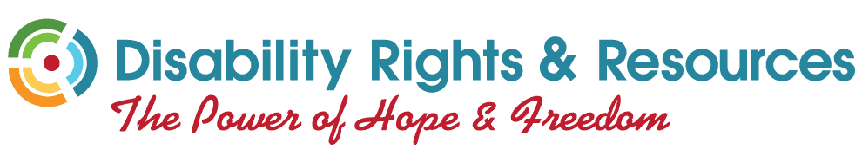Independent Living Centers: Disability Rights and Resources , Montgomery and Mobile ILC

1. Mission of People First and issues are becoming even more similar, so work together on these issues
2. Work on the Employment First Campaign
3. Participate on Advisory Committee for People First and perhaps OCSS
4. Consider additional support in starting chapters with a youth focus

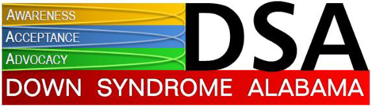

Other Groups:

1. Downs Syndrome Alabama -Expand dialogue around chapter development.
2. Siblings Network: Consider the development of Siblings chapter in Alabama with focus on youth and self-advocacy development
3. Continue to support collaborative efforts with youth with mental health needs.

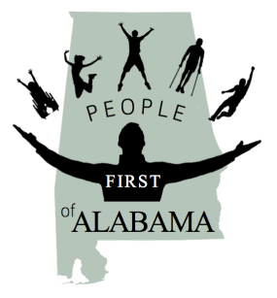

**It Takes A Village!**

**August 20, 2014**

9:00 AM -9:30 AM

C:\Users\ADM01\AppData\Local\Microsoft\Windows\Temporary Internet Files\Content.IE5\3V8DWY9Z\MC900104882[1].wmf Welcome and Introductions

Nikki Dawson, People First of Alabama and Bryon Murray Self Advocates Becoming Empowered (SABE)



Ice Break: Elevator Speech

Chaqueta Stuckey and Teresa Moore SABE

9:30-10:00 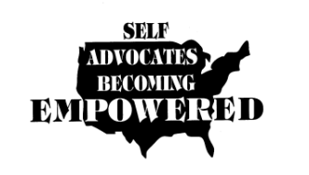

Overview of Self Advocates Becoming Empowered and Our Community Standing Strong (OCSS)

Bryon Murray and Chaqueta Stuckey Self Advocates Becoming Empowered and Our Community Standing Strong

10:00-10:30 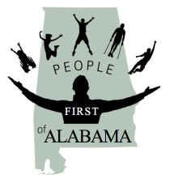Review of Alabama State Technical Assistance plan form the OCSS Project and brainstorming on how DD partners can support the efforts

Nikki Dawson, People First of Alabama and Chaqueta Stuckey, SABE

10:30-10:45 break

10:45 AM -11:15 AM

C:\Users\ADM01\AppData\Local\Microsoft\Windows\Temporary Internet Files\Content.IE5\Y60YF16C\MC900384392[1].wmfPartnership Building

Tia Nelis, SABE Project Vote Team and Richard Chapman, FLSAND and OCSS Advisory Committee Member  
  
11:15 AM -Noon

Project Vote: How Can Alabama Get Involved?

SABE’s Project Vote Team: Nancy Ward, Tia Nelis, Teresa Moore, Essie Pederson and Juliana Huerena  
  
Noon-1:00 PM Lunch- Get to know Everyone



1:00 PM -3:00 PM

YEL-Youth Issues, Increasing Diversity of our membership, Building our membership: General Discussion

Teresa Moore and Juliana Huerena SABE

Nicole Le Blanc Autism Now and Green Mountain Self Advocates

3:00 PM -4:00 PM

C:\Users\ADM01\AppData\Local\Microsoft\Windows\Temporary Internet Files\Content.IE5\FUE1ZU4H\MC900056986[1].wmf

Next steps: How do support grassroots self advocacy in Alabama?

Chaqueta Stuckey and Nikki Dawson

This meeting was made possible by a grant from the Alabama Council on Developmental Disabilities.

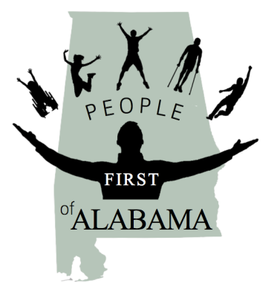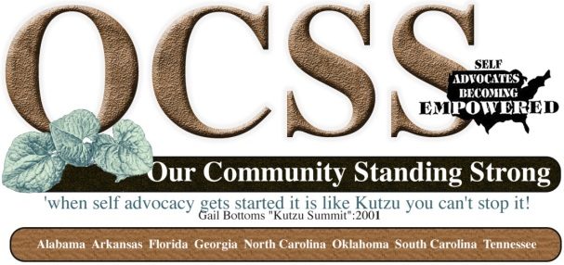

**“Self Advocacy: It takes a Village!”**

**August 20, 2014**

**Sponsored by People First of Alabama, Alabama Developmental Disabilities Council, YEL, Self Advocates Becoming Empowered and Our Community Standing Strong**

**Participants**

**Organization Represented and Roles**

**Alabama:**

**People First Board and YEL Leaders**

Nikki Dawson

Matthew Foster

Josh Whitmire

Lauren Kimbrell

Mathew Foster

Britney Gore

Elouise Woods

Erin Johnson

Darren Morris

Rebecca Alexander

**People First Staff and Support**

Brenda Doss

Susan Ellis

Chris Ballard

Jasmine Jones

Mike Foster

**Alabama Downs Syndrome Association**

Sue Tolle

**Disability Rights and Resource Center**

Dan Kessler

**Alabama Department of Mental Health**

George Neal

**Development Disabilities Council of Alabama**

Myra Banks

Holli Cawthorne

**Alabama Disability Advocacy Program**

James Tucker

Patrick Hackney

**University of Alabama UCEDD**

Cindy Sweeny

Graham Sisson (Governor’s Council on Disability)

**Self Advocates Becoming Empowered and Our Community Standing Strong**

**Officers:**

Bryon Murray –President (Utah)

Betty Williams-Secretary (Indiana)

Ryan Duncanwood-Treasurer (California)

Chaqueta Stuckey Sgt. At Arms and Co-Director of Our Community Standing Strong (South Carolina)

**Region 6 and 9 Representatives and Alternates/Our Community Standing Strong Advisory Board Member**

Bernard Baker -Georgia

Eric Treat –Arkansas

Darren Morris -Alabama

**OCSS Advisory Members:**

Richard Chapman-Florida

Lauren Kimbrell -Alabama

Nikki Dawson -Alabama

Nancy Ward –Oklahoma

**SABE Advisors and Staff**

**National Advisors**

Juliana Huerena-Arizona

Glenda Hyman Singletary-South Carolina

**Project Vote**

Nancy Ward-Oklahoma

Tia Nelis-Illinois

Teresa Moore-Arizona

Essie Pederson-Ohio

**Autism Now**

Nicole LeBlanc

**Our Community Standing Strong**

Chaqueta Stuckey-South Carolina

Vicki Hicks Turnage Alabama