**QUARTERLY REPORT COVER SHEET**

|  |  |  |
| --- | --- | --- |
| 1 | **Grant Number** | 90DN0331-01-00 |
| 2 | **Project Title** | “Our Community Standing Strong” (OCSS)  A Regional Technical Assistance Center for the Southern Collaborative |
| 3 | **Grantee Name & Address** | 4401 West Northwood Lake Dr.  Northport, Al. 35473 |
| 4 | **Telephone number** | 205-310-4839 |
| 5 | **Project Period** | October 1, 2013-September 30, 2014 |
| 6 | **Reporting Period** | April 1, 2014- June 30, 2014 |
| 7 | **Project Director/Principal Investigator** | Vicki Hicks Turnage |
| 8 | **Report Author** | Chaqueta Stuckey  Vicki Hicks Turnage |
| 9 | **Telephone** | Chaqueta Stuckey: 843-319-0118  Vicki Hicks Turnage: 205-310-4839 |
| 10 | **Date of Report** | April 21, 2014 |
| 11 | **ACL Program Officer** | Katherine Cargill-Willis |
| 12 | **ACL Grants Specialist** | LaDeva Harris |

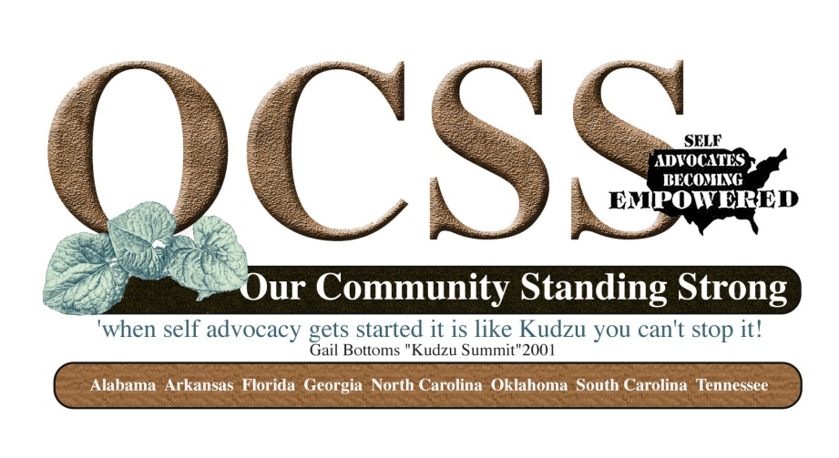

**SECTION 1**

|  |  |
| --- | --- |
| **Goal 1**    To provide regional technical assistance to strengthen the participating states capacity to increase and support self advocacy through relationships and partnerships at the community level. | |
| Objectives  C:\Documents and Settings\Katherine.CargillWi\Local Settings\Temporary Internet Files\Content.IE5\HYWMHL8B\MM900234700[1].gif | * 1. Identify capacity of SABE and participating states to provide peer advocacy and mentoring.   2. SABE and participating states identify resources and provide opportunities for training and leadership development for and by participating states.   3. SABE supports states in providing education and outreach to their local groups and community. |
| Activities  C:\Documents and Settings\Katherine.CargillWi\Local Settings\Temporary Internet Files\Content.IE5\UOH8537N\MC900440201[1].wmf | * 39 attended the advisory Committee meeting in Birmingham on May 8-10, 2014. The group worked on their state technical assistance plans and visited the Birmingham Civil Rights Museum and the Disability History Exhibit sponsored by Disability Rights Center, People First of Alabama. * There were 8 DD Network Partners and other state partners represented from Alabama, North Carolina and Tennessee. * We had representatives from the UCEDD at Vanderbilt University, Alabama and North Carolina DD Councils, P and A’s from Alabama and Tennessee, and a state DD representative from Alabama. * The meeting provided the states with a structure to develop their sate plan. Prior to the meeting a webinar was also hosted by the project to provide additional structure for the development of the technical assistance plan. Julie Petty, Arkansas could not attend but presented via Skype on Tips for your state plan. * As of June 30, 2014, seven of eight states have completed their surveys. Current count for submitted surveys is 1293. Our goal was 1200 surveys. * Committees and Advisory Committee met via Go To Meeting and Webinars * Dates of these events: * April 22: How to develop a plan? Presented by OCSS Staff * May 27: How can our DD Partners Help Us: Strategies for Building Partnerships? Presented by Tennessee State Team, Tia Nelis and OCSS Staff * June 24: (Changed to July 1, 2014 due to conflict) Funding Strategies: Presented by all states and OCSS * Scheduled Advisory Committee Meetings and Webinars:   1. July 22: Writing Grants: Florida and OCSS State Team Members   2. August 26 Keeping Granting: Florida and OCSS State Team Members   3. August 19-22 Alabama Technical Assistance by OCSS staff and selected OCSS States and Executive Committee of SABE   4. TBD Blogging- Getting your message out! South Carolina * Seven of eight states have submitted their first Vlog. Vlogs should be released by end of July.   1. Topics of Vlogs were: Introduction to the OCSS project, employment, children in nursing homes, working with legislators and policy makers, closing institutions. * Provided one on one consultation by phone and e-mail to self-advocacy organizations and partners to Alabama, Arkansas, Tennessee, Georgia, North Carolina, Florida, Oklahoma and South Carolina. * We are still working with website developer to post all work from project to OCSS page. * Posted events on SABE Facebook page * Adopted OCSS Logo (Alabama P an A- ADAP assisted with logo design) |
| Outcomes  C:\Documents and Settings\Katherine.CargillWi\Local Settings\Temporary Internet Files\Content.IE5\1DMY56TI\MC910217623[1].wmf | 1. Advisory Committee has met Face to Face and by Webinars 3 times during quarter. The next Advisory meeting will be held at the National Self Advocacy Conference in Oklahoma City October 9-12, 2014. 2. 1293 needs assessments collected as of June 30, 2014. Only one state did not complete their surveys. Survey Goal: 1200 <https://www.surveymonkey.com/results/SM-33MJSKT/> 3. Peer to Peer Technical Assistance have been provided by representatives from state organizations and their allies 4. States also participated in the Webinars on developing their state plan, how can our DD Partners Help Us: Strategies for Building Partnerships? 5. States produced 8 Vlogs. Currently in process of posting to SABE You Tube Station   <http://www.youtube.com/playlist?list=PLHe4SX3HJvyt8jUw4e5BzvfquH-2M1rXg> |

**SECTION 2**

**Collaborations**

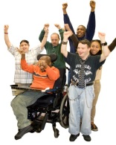

1. ASAN and NEAT met by conference call in April by conference call. The topics of discussion included a joint presentation on use of technology by projects at the National Self Advocacy Conference in Oklahoma. A proposal was submitted for the presentation and accepted.
2. OCSS will present with ASAN and NEAT at Reinventing Quality Conference in Baltimore in August.
3. Vanderbilt University UCEDD has been extraordinary in reaching out to collaborate with our project. This has included the participation of two staff from the University. In addition, the project provided technical assistance to Vanderbilt in the area of how to support self advocacy in Tennessee. The Center offered to develop a survey to be used to gather information for other UCEDD’S in participating state on how they supported self advocacy.
4. Tennessee P and A sent a representative to the Birmingham Advisory Meeting.
5. ADAP-Alabama (P and A) and DD Council representatives attended the Advisory Committee Meeting in Birmingham. In addition, ADAP provided our group with a vehicle and a Driver (one of lawyers and the Director) to transport the group to dinner and to the Birmingham Civil Rights District. The DD Council also paid for the hotel expenses for two of our presenters at the Advisory Committee Meeting in Birmingham and accessible taxi’s for the group use.
6. People First of Alabama sponsored the entry fee to the Birmingham Civil Rights Museum and sponsored our lunches for the meeting.
7. Georgia’s P and A supported their representatives attendance through the rental of a vehicle for their representatives to attend the meeting
8. Alabama Department of Mental Health Director of Self Advocacy Services attended the Advisory Committee meeting in Birmingham.
9. In addition, the Alabama DD Council invited members of the OCSS Advisory Committee and the SABE Executive Committee back to Alabama to provide Technical Assistance to People First and the DD Partners. This is scheduled for August 19-22 in Birmingham. The attendees will also be conducting workshops, Keynotes and participating on panels at the People First of Alabama conference on August 21-22.
10. Collaborated with University of Massachusetts on Diversity Institute (AIDD RFP Project of National Significance). If funded OCSS would receive some funds for 5 years to continue the work in these states
11. Collaborated with Georgetown University on Diversity Institute (AIDD RFP Project of National Significance). If funded members from OCSS may be chosen to participate in Institute and to assist in wisdom council.
12. Explored collaboration with private consultation group on Supported Decision Making (AIDD RFP of National Significance). Did not have enough time to complete ground work for submission.
13. Sibling Leadership Network continues to be supportive.

**SECTION 3**

**Problems**

1. SABE Website is in process of reconstruction so the project has been delayed in establishing a page for Our Community Standing Strong. We have made progress but still do not have a functional page.
2. One state self advocacy group continues to have problems with survey completion and plan development. Our team is working with this state and there partners.
3. Internal communication and interactions within state organizations continue to be a problem.

**SECTION 4**

**PRODUCTS THAT HAVE BEEN DISSIMINATED**

**IN THE LAST THREE MONTHS**

1. Financial report for quarter
2. Minutes for Advisory Committee Meeting in Birmingham-May 8-10
3. Webinars are ready to be posted on website
4. State Technical Assistance Plans
5. PowerPoint presentation on How to Develop a State Technical Assistance Plan
6. Individual State Demographic Surveys/Initial Technical Assistance Plan
7. SABE Nation released after end of quarter featured article on the Our Community Standing Strong Project.

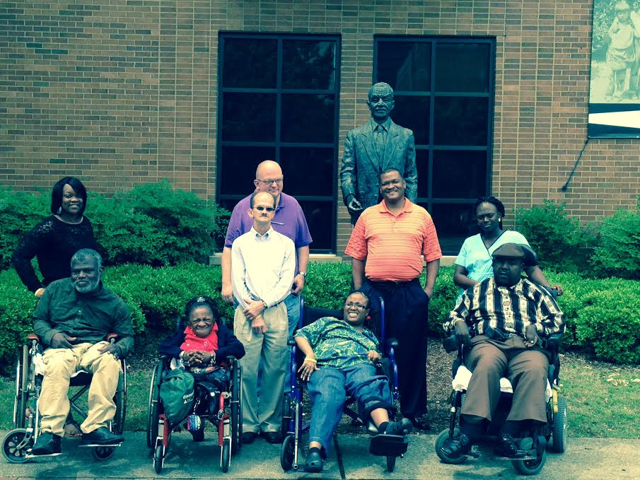

**Members of the OCSS Advisory Committee at the Birmingham Civil Rights Museum**