

**Minutes**

**Our Community Standing Strong Advisory Committee Meeting and Regional Meeting**

**Date: July 5-7, 2016**

**Meeting was held at the**

**Embassy Suite-Orlando Airport**

**5835 TG Lee Blvd**

**Orlando, Florida 32822**

**Attending: See sign in sheet.**

**Tuesday July 5, 2016**

**3:00 PM-3:45 PM** 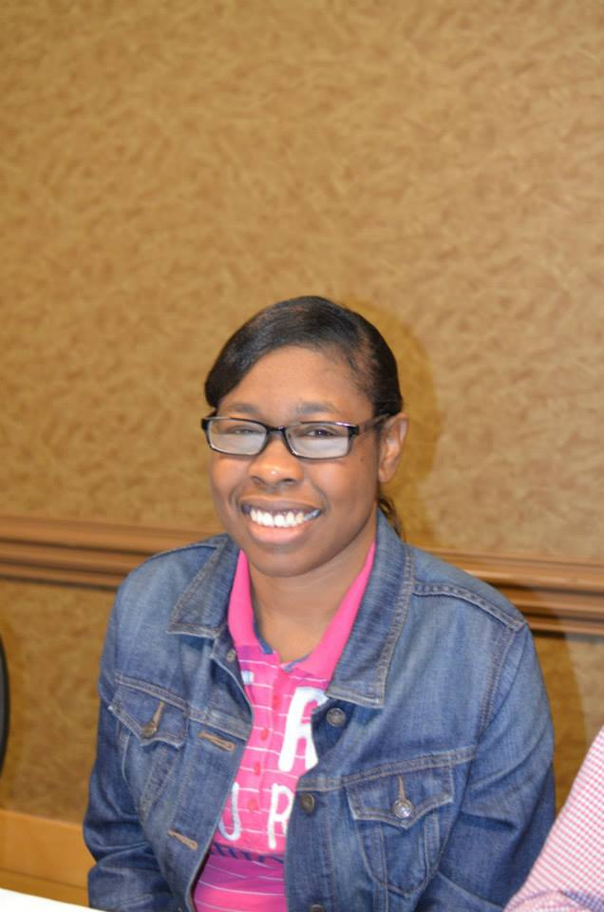

**Chaqueta welcomed everyone to Orlando.**

** Moment of Silence was offered in memory of all of the lives that were loss in the Pulse Tragedy.**

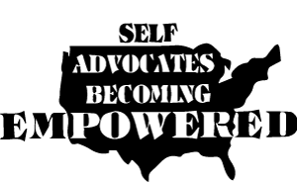**SABE Update:**

**Team Building Activity**

Chaqueta facilitated a team building activity. The group was divided into four groups. The activity was designed to continue our theme of leadership and team development.

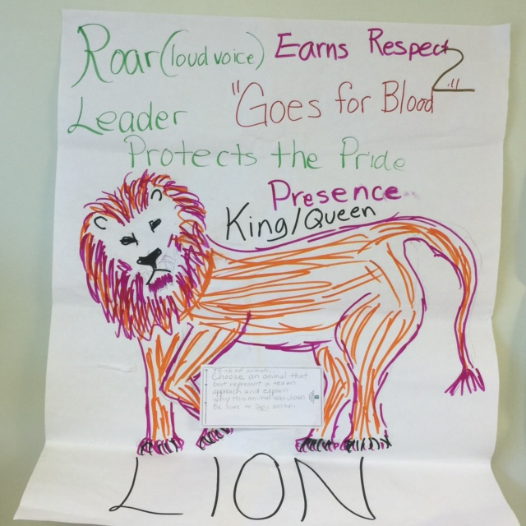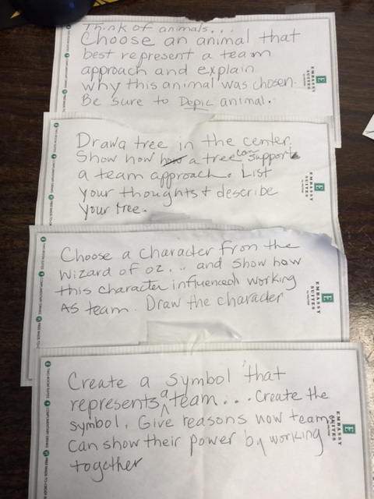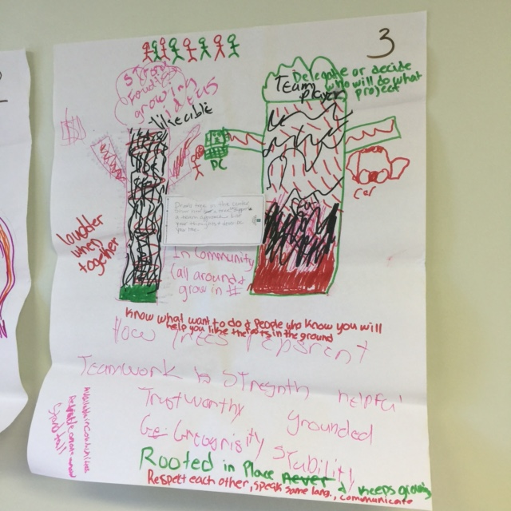

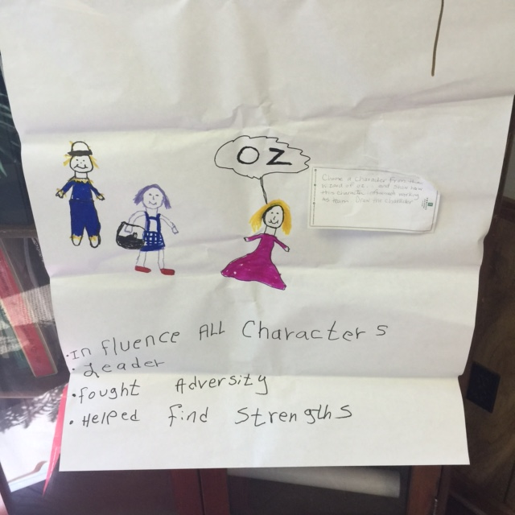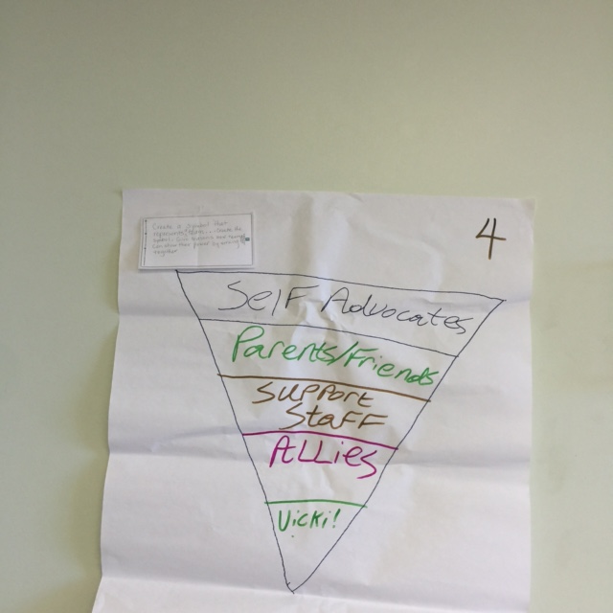

**State of the States:**

****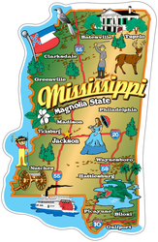****

See attached for updates from states.

**3:45 PM- 5:00 PM** 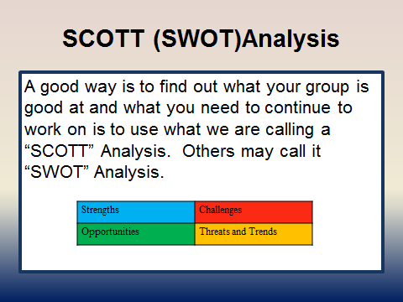

Sustainability: The group reviewed their work on sustainability and the important activities from Our Community Standing Strong that they wanted to continue.

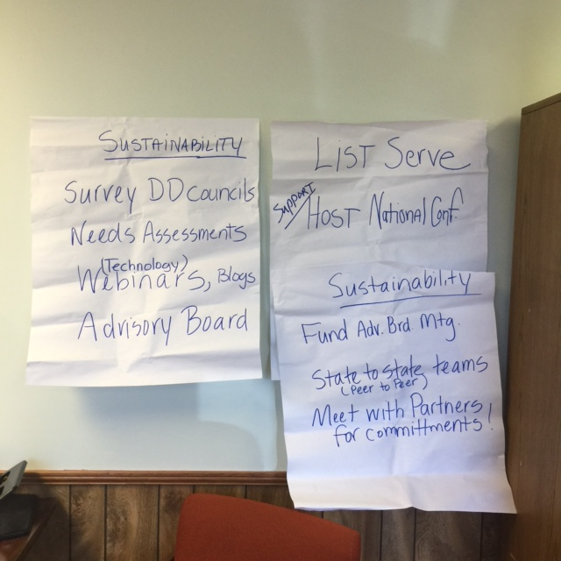

We made videos about each state’s biggest challenges to keeping the self advocacy movement strong.



**Wednesday July 7:**

********

See attached notes from each state.

**National Self Advocacy Resource Center:**

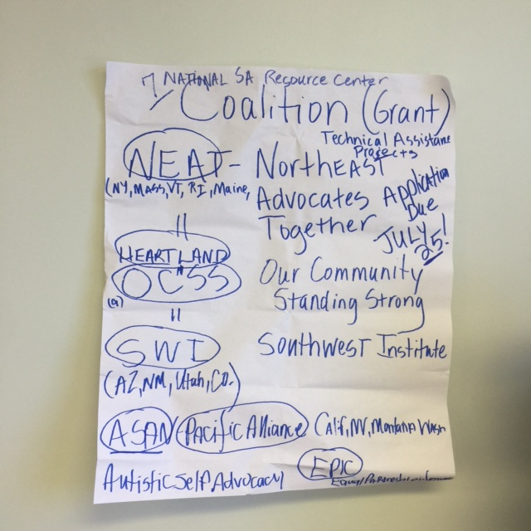

Tia and Chaqueta talked about SABE’s application to AIDD for the National Self Advocacy Resource Center. The participants were excited about the project and the fact that it would continue to support the technical assistance activities of OCSS. All participants signed a letter of support for the Center.

**Our Final Sustainability Plan:**

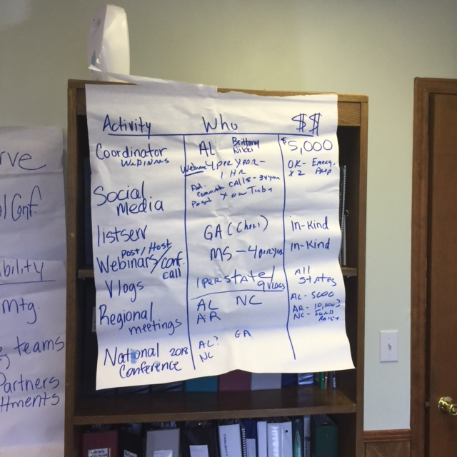



October 1, 2016 to September 1, 2017

| **Activity** | | **Who responsible** | **How many** | **How much** |
| --- | --- | --- | --- | --- |
| Coordinate activities:  Announcements  PowerPoints  coordinate topics  Prep speakers | | AL  Brittany  Nikki | Manage:  4 webinars  4 vlogs  3 call  1 Face to face meetings | $5,000 from DD Council |
| Social Media  Facebook, etc.… | | SABE |  |  |
| Vlogs  2-3 minutes | | 2 minimum per state | 4 AL  4 SC  4 GA  4 NC  2 FL  4 AR  2 OK  ? TN  4 MS | **Topics**  Transportation  Housing  Employment  CMS rules  Accessibility  Speedbumps  Crosswalks  Volunteering  Freedom  How to speak out  Robert Rules of order  Social relationships  Business social etiquette  Elephant in the Room (sex)  Relationship with PCAs  Leader -assertive, passive, and aggressive  Technology  Elevator speeches  Emergency Preparedness  PF language  Voting  Marriage penalty  ABLE Act  Giving back to the community  Red Cross  Education options, Project SEARCH  Accessibility in voting  Benefits, ticket to work  Supported decision |
| Webinars | 4 per year  Panel format | OK, Emergency Preparedness | In kind  Topics like vlogs | |
| Conference calls | AL, free services | 3 Advisory meeting calls  1 hour | In kind | |
| Regional Summit or Conference maybe with an outcome  Mitsubishi, Technology  Youth Grant | All states | 1 per year | Cost about $50,000 to $100,000  AL $5,000  AR $10,000  NC fund raise  GA $??? | |
| SABE 2018 National Conference | AL  GA  NC  FL  MS |  | Cost about $500,000  Need upfront money $50,000 | |

**Previewed Technology Video by NEAT**

**8 Video blogs were produced featuring advisory committee members reflecting on the biggest challenges and successes of their organization.** [**https://www.youtube.com/playlist?list=PLHe4SX3HJvyt8jUw4e5BzvfquH-2M1rXg**](https://www.youtube.com/playlist?list=PLHe4SX3HJvyt8jUw4e5BzvfquH-2M1rXg)

**A video blog was produced by representatives of the advisory committee on their thoughts on the following questions as a part of the final evaluation of the project:**

* What have you learned for your involvement with OCSS?
* What words of wisdom do you want to give other self-advocacy organizations/groups who want to work together?
* ­­­­­­­­­­­­­­­How will use what you have learned in your lives and in your support of the self advocacy movement?
* What one word describes your experience with OCSS?
* What is the most important activity of the OCSS project that we need to sustain?
* Why is it important to sustain the activities of OCSS?

**We will also send out a survey to all members based on these questions.**

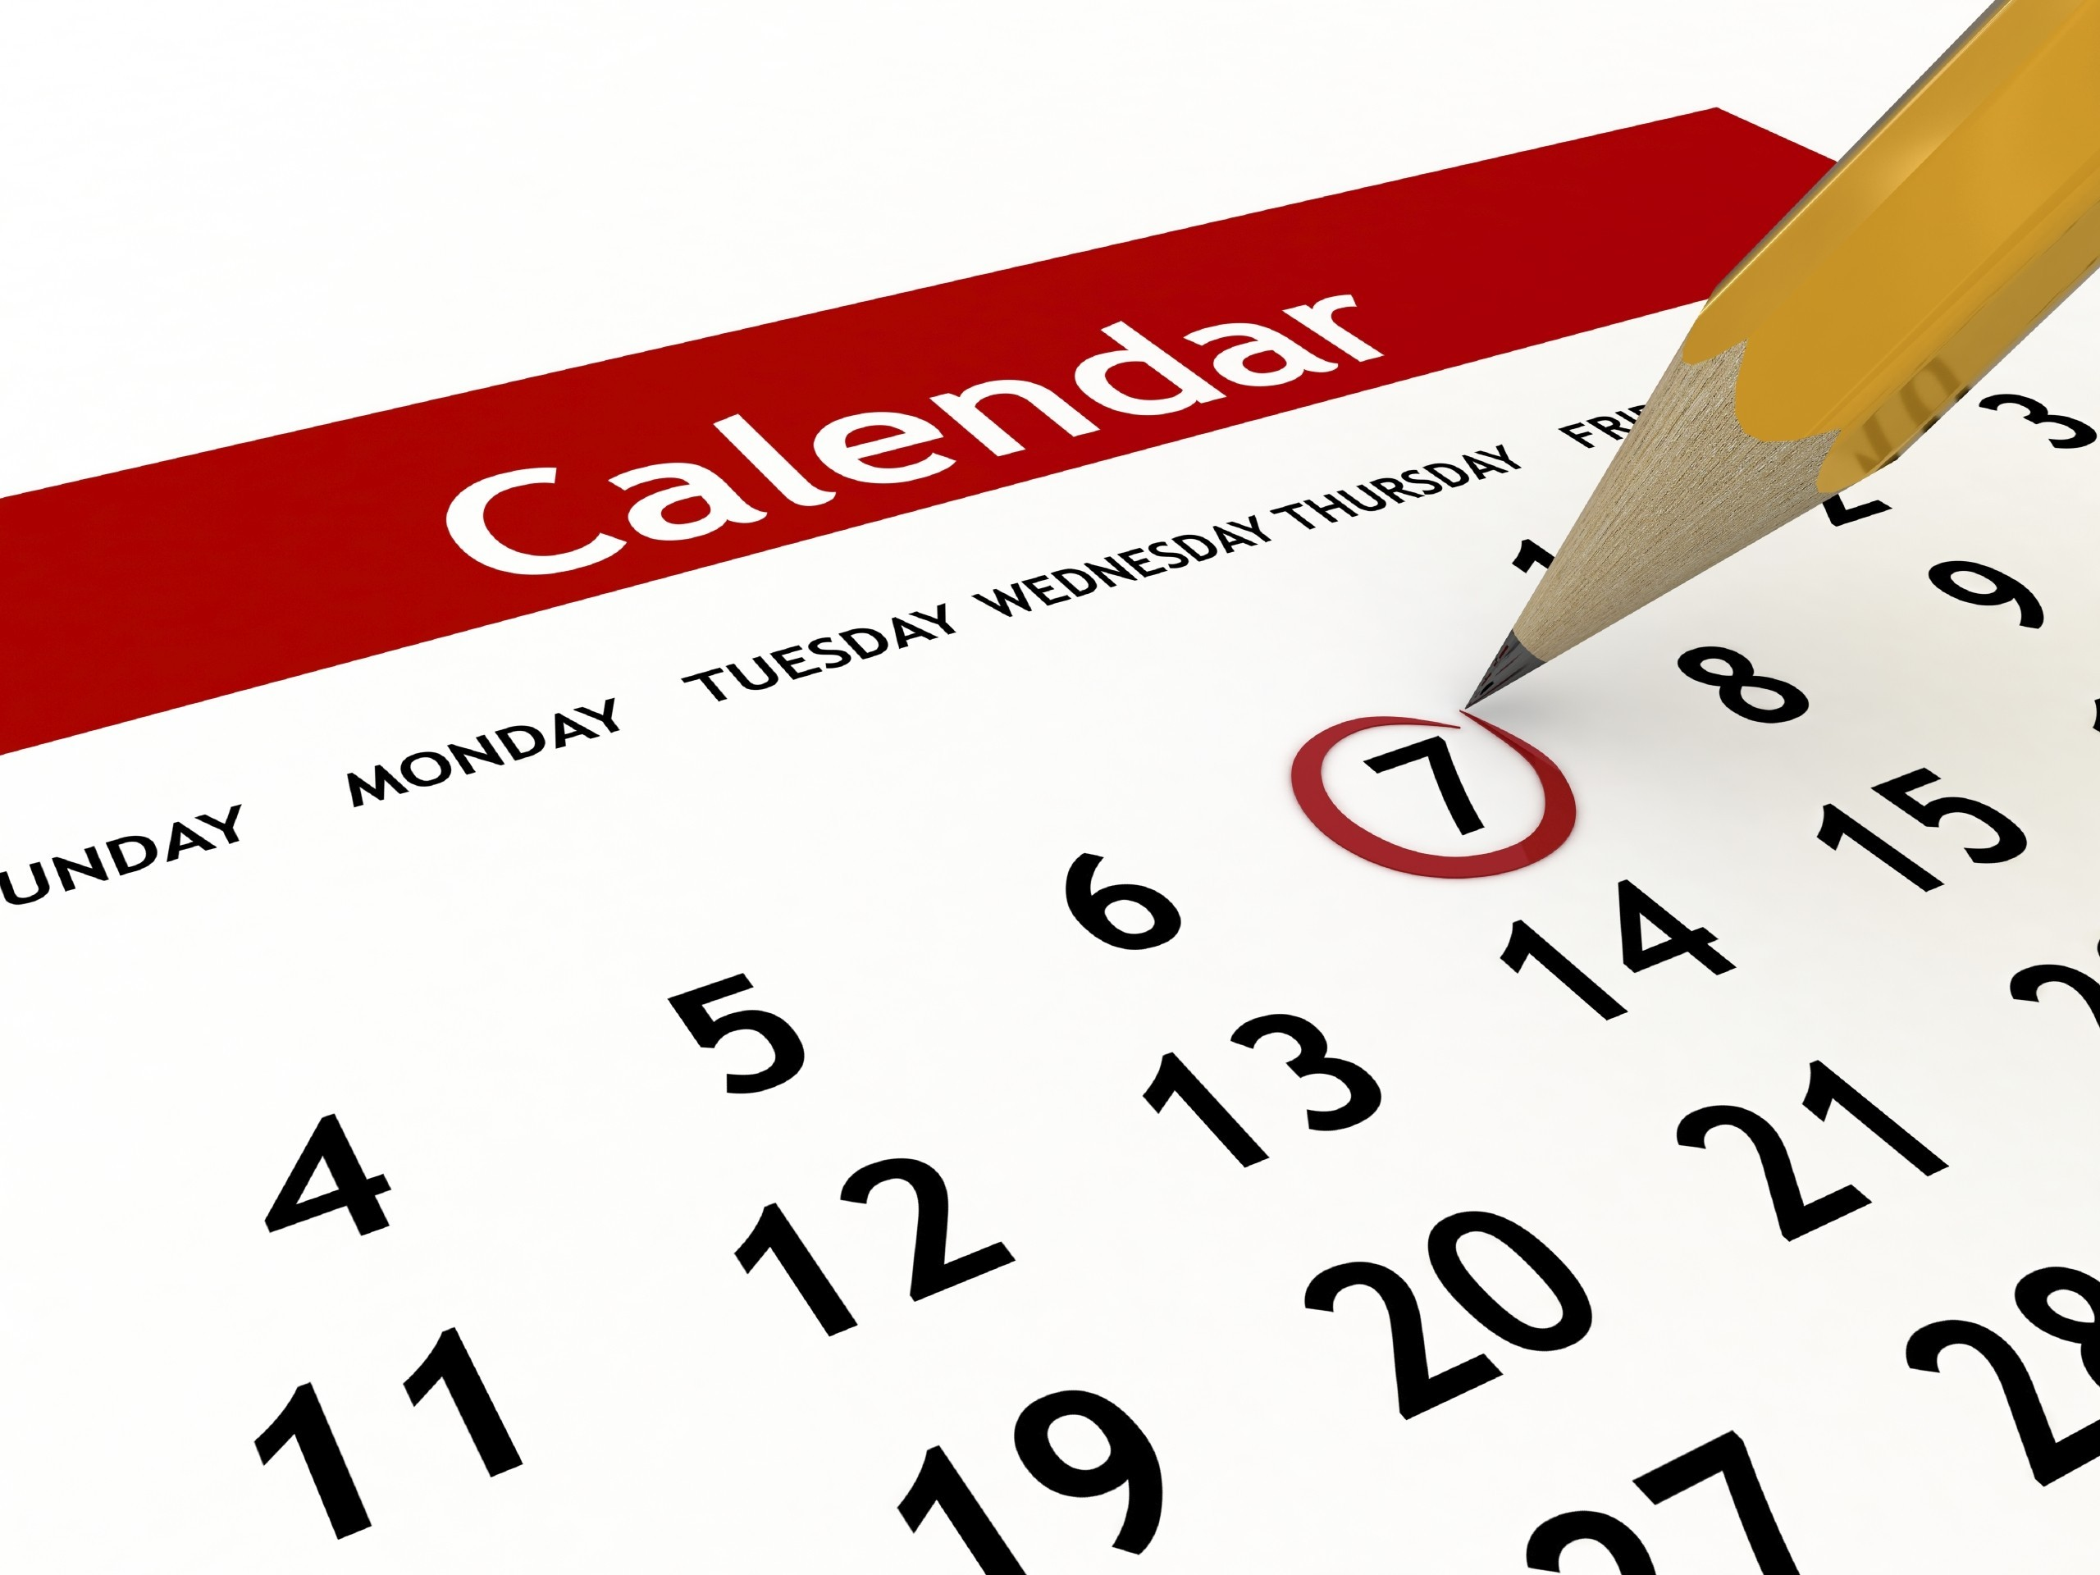 **Discussed Important Dates and Activities**

* **Due Now**  3rd.Quarter Invoice quarterly report on Plan and 2nd Vlog
* **September 15th** 
  + 4th Quarter Invoice
  + **final report on plan**
* 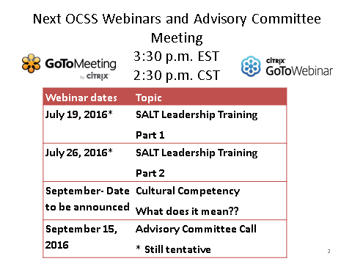

**Optional Meeting:**

**July 7, 2016 9:00-11:30**

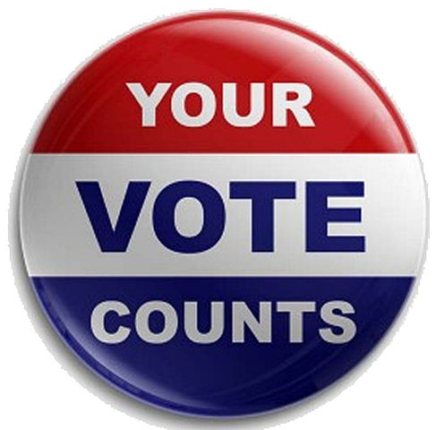**SABE Vote Project, OCSS states meets and shares ideas with Tom Hicks, Commissioner of Elections Assistance Commission.**

**Representatives from Alabama, Arkansas, Florida, Georgia, North Carolina, Oklahoma, South Carolina, and Tennessee attended Project Vote.**

**Minutes by**

**Vicki Hicks Turnage**

**Vicki Hicks Turnage**

**Participants for Advisory Committee Meeting**

|  |  |
| --- | --- |
| **Alabama**  Nikki Dawson*  Brittany Gore*  George Neal  Darren Morris  Susan Ellis | **Arkansas**  Mike Thornton*  David Deere |
| **Florida**  *Arizona Jenkins  Pamela Brown | **Georgia**  *Bernard Baker*  *Teresa Coleman  Lashonda Hines |
| **Mississippi**  *Cindy Singletary  * Taylor Carley  Dan Lewis  Jerry Alliston | **North Carolina**  David Taylor, Jr*  Judy Taylor  **Participating by phone**  * Ellen Perry* |
| **South Carolina**  Ebony De Loach *  Sonya Gilmore  Angela Green | **Oklahoma**  Nancy Ward *  Dee Banta*  David Bridges  **Renita Bridges** |
| **Tennessee**  Bill Gage *  Sam Gage*  Laurie Robertson and Emma Baxter  Carol Rabideau (participating by phone on July 5. | **SABE**  Chaqueta Stuckey  Glenda Hyman Singletary  Juliana Huerena  Bill Lucerno  Vicki Hicks Turnage |

* Denotes Advisory Council Member

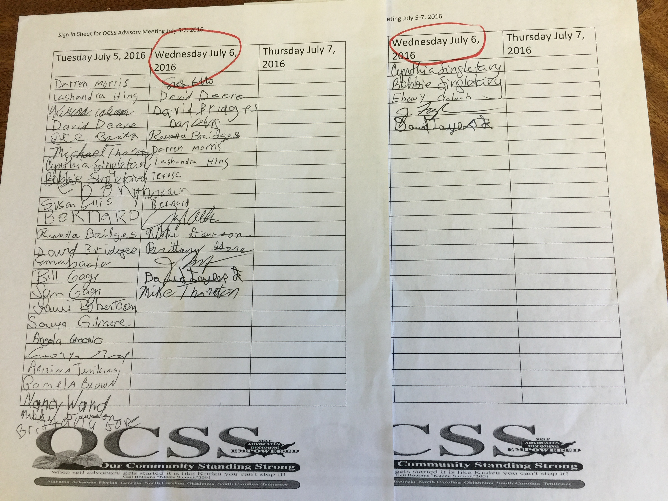

**Attachment: State Reports**

**Alabama**

Brittany Gore and Nicki Dawson reported for Alabama. See attached report.

**Arkansas:**

Michael Thornton and Glen Deere indicated that Arkansas is working on rebuilding and will still try to complete surveys and produce 3 vlogs prior to the end of the project. A new cross disability self advocacy coalition has formed facilitated by Julie Petty.

In addition, Chaqueta Stuckey, Glenda Singletary and Bill and Sam Gates from OCSS and Tia Nelis, SABE President will provide on-site technical assistance for People First of Arkansas and the Self Advocacy Coalition on August 23, 2016 in Little Rock.

**Florida:**

Arizona Jenkins reported that FLSANDS is working with a new provider who will provide a facilitator for group and act as their fiscal intermediary. They will be revisiting the deliverables for their grant. In addition, FLSANDS supported the advisory committee by providing lunch for the group.

**Georgia:**

Bernard Baker and Teresa Coleman reported on PF of Georgia’s activities. Highlights included their state conference August 26-28. Chaqueta will be the Keynote Speaker. PF of Georgia continues its efforts to promote implementation of Olmstead through its Long Road Home Activities. Brad Smith produced a video on the History of Olmstead and their activity to celebrate the Olmstea Act. They are also working on a campaign for equal pay and employment for all. In March PF of Georgia promoted self advocacy through contacts with their legislators. They also produce a vlog

**Mississippi:**

Cindy Singletary highlighted Mississippi’s efforts to reach out to youth. Taylor Carley is producing a vlog series on topics on a weekly basis.

**North Carolina**

David Taylor, Jr. highlighted their accomplishments. Discussed NC interest in voter project. They are also continuing efforts to promote People to People to promote more involvement on the grassroots level.

Vlogs produced include:

* How to Safely Cross the Street
* A two part series on How to Vote

Sponsored a booth at the NC Council of Community Program to spread the word about People First and what we are doing

The local Chapel Hill/Carrboro and the Charlotte groups have been going out in the community and checking doors to see how heavy they are. Because of this, some businesses have agreed to readjust heir doors to make them more accessible.

**Oklahoma**

Dee Banta reported that Oklahoma has continued to work on their SALT training and has developed materials. They are also conducting Emergency Preparedness training. They will present webinars on these subjects at end of July and in October.

**South Carolina**

Ebony Deloach highlighted South Carolina activities. Ebony and Chaqueta participated in a Leadership Training Academy with the Independent Living Center.

**Tennessee**

Bill and Sam Gage shared Tennessee’s accomplishments. See Attached.