**Minutes**

**Our Community Standing Strong Advisory Committee Meeting**

**Cox Convention Center Oklahoma City, Oklahoma**

**Date: Saturday October 11, 2014**

**10:15 AM – 11:30 AM Room 15**



**Social Media: Blogging, Vlogging and Other Tips-**

**Regional Self Advocacy Technical Assistance Projects will share their experiences with Social Media.**

**Our Community Standing Strong staff and advisory board member Eric Treat along with representatives from Northeast Advocates Together Skye Peoples, Hillary Clark (by vlog) and Ann Fracht presented on the use of social media to communicate on issues. Also, the panelist demonstrated how easy it is to produce a vlog. Posted a vlog on conference to you tube. In addition, Teresa Moore (SABE Project Vote) and Eric Treat introduced the SABE Technology Handbook to group, The participants received a copy of the Handbook. We will also produce a Vlog.**

**There were 39 participants in the meeting from the participation OCSS states and other states in attendance at the conference.**

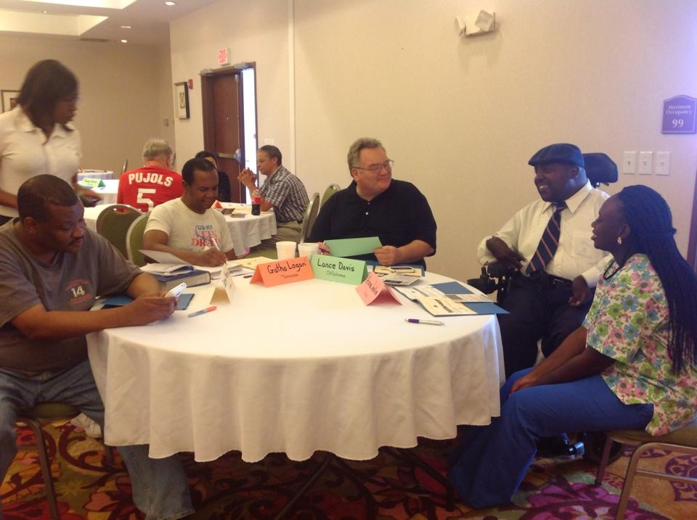 **Review of State Plans for Technical Assistance including Work Plan with Objectives and Action Steps:**

**Alabama and Tennessee presented their plans with objectives and action steps for the group to discuss. This exercise provided an opportunity for states to ask questions and clarify issues related to the plans.**

**States are required to complete a quarterly update on plan.**

**C:\Users\ADM01\AppData\Local\Microsoft\Windows\Temporary Internet Files\Content.IE5\3V8DWY9Z\MC900024297[1].wmfChaqueta and Vicki reviewed of Contracts and Invoice for 2015:**

**Contract requirements for 2015 (items in *italics are new.)***

1. Participate in the advisory committee by *maintaining membership on the committee of a minimum of two self advocates*
2. Attend two face to face advisory committee meetings

* *October 8-12 Oklahoma City*
* *March, 2015 location and exact date to be announced*

1. *Assure participation of at least one representative and one ally in webinars*
2. *Participate in planning and present at least one webinar*
3. Obtain the commitment of at least one DD Network Partner to support the implementation of the state Technical Assistance Plan
4. *Hold a retreat with DD Partners and other Allies in your state*
5. Produce at least 2 *Vlogs*from your state on issues of concern
6. Post the activities of your self-advocacy organizations on SABE website, Facebook and Twitter
7. Develop and implement state training and technical assistance (T/TA) work plan *to include 8 state and local events on priority state issues.*
8. Commit to publically share their successes and lessons learned, training plans and products on [www.sabeusa.org](http://www.sabeusa.org)
9. Obtain DD Network Partners to assist with the development of the project’s sustainability plan to continue the regional self-advocacy collaboration efforts
10. *Obtain at least one grant for your organization to work on priority issues*

**Invoices are due on a quarterly basis, with the exception of travel assistance for this meeting. The payment schedule is as follows:**

* *October 31, 2014: Invoice and supporting documentation for $500.00 Travel Assistance for October Advisory Committee in Oklahoma City.*
* *December 30, 2014: $1250.00 Invoice and state plan quarterly report*
* *March 30, 2015: $1250.00 Invoice and state plan quarterly report*
* *June 30, 2015: $1250.00 Invoice and state plan quarterly report*
* *September 18, 2015: $1250.00 Invoice and state plan quarterly report*
* *Invoices shall be submitted to Vicki Hicks Turnage at 4401 West Northwood Lake Drive Northport, Al. 35473. Invoices must be accompanied by certification of completion of requirements as specified in Section D of contract. Checks will generally be issued within 30 days of receipt of Invoice.*

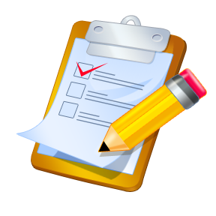**Other Topics on agenda were not discussed due to lack of time. These will be discussed in November by webinar/Go To Meeting.**

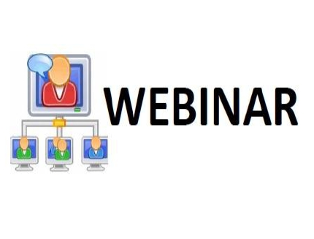**Webinar Topics for Next Year**

**C:\Users\ADM01\AppData\Local\Microsoft\Windows\Temporary Internet Files\Content.IE5\3V8DWY9Z\MC900436984[1].wmfC:\Users\ADM01\AppData\Local\Microsoft\Windows\Temporary Internet Files\Content.IE5\943LKUJ8\MC900436970[1].wmfC:\Users\ADM01\AppData\Local\Microsoft\Windows\Temporary Internet Files\Content.IE5\FUE1ZU4H\MC900436972[1].wmfC:\Users\ADM01\AppData\Local\Microsoft\Windows\Temporary Internet Files\Content.IE5\Y60YF16C\MC900437425[1].wmf New States: How do we include in Project?**

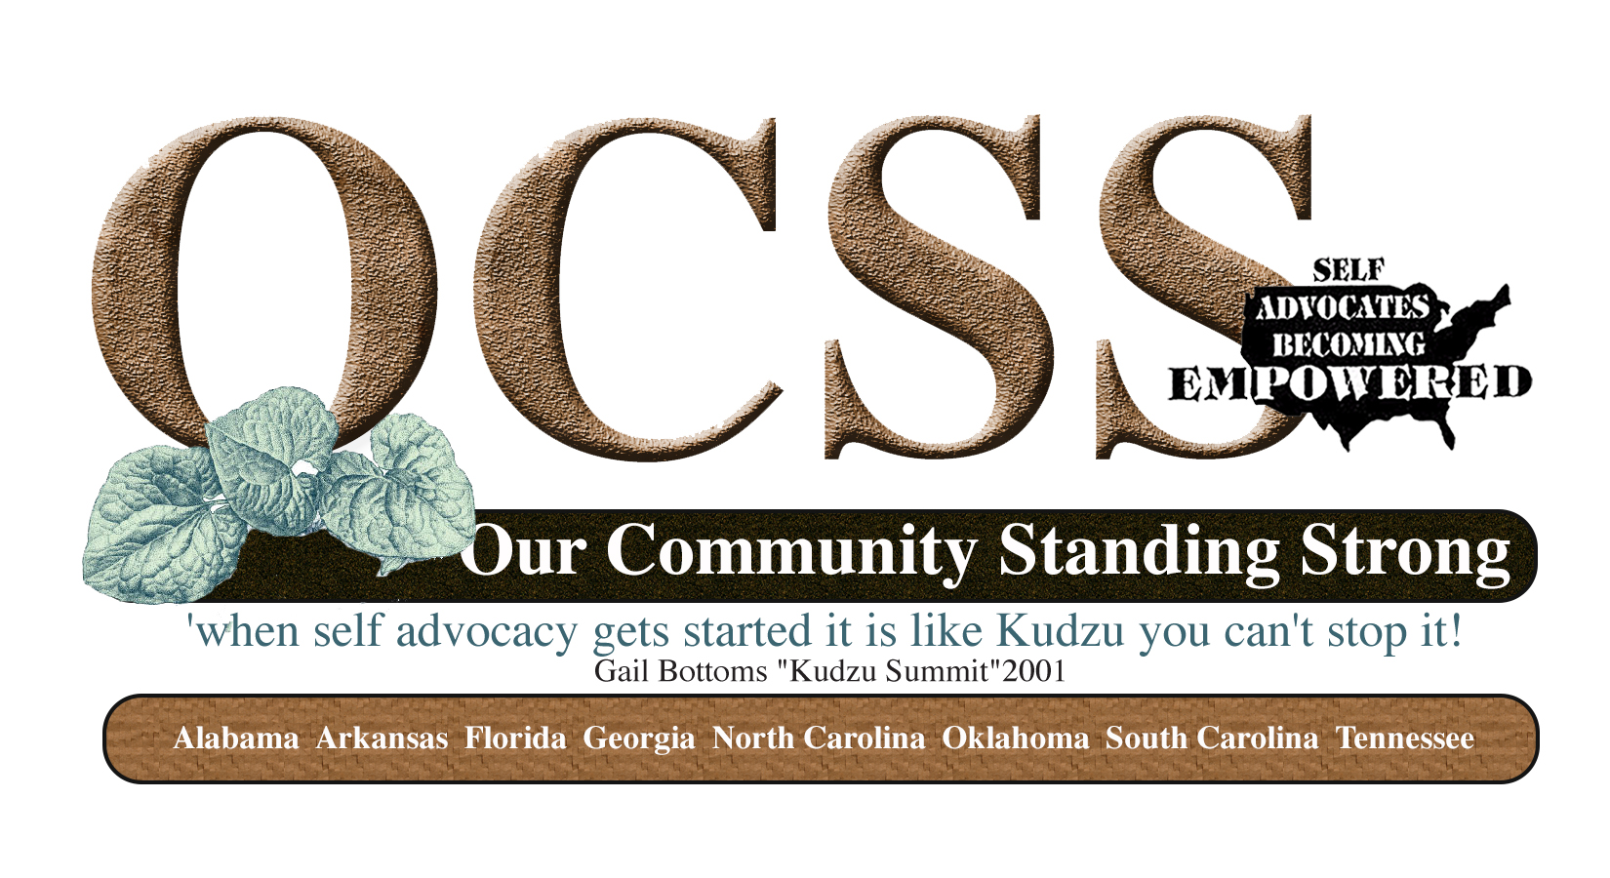**Regional Project**

** Location and Date of March Meeting**

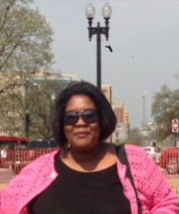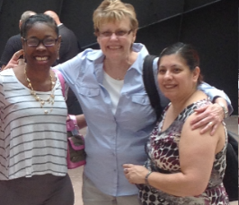 **Meeting was facilitated by Chaqueta Stuckey and other members of OCSS Team**