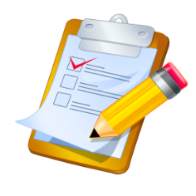

**Date: November 19, 2014**

**Time: 2:30-4:00 CST, 3:30-5:00 EST**

**Place: Go To Meeting**

**Topics**

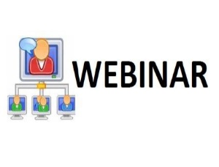

**What Topics are we interested in for Next Year?**

**C:\Users\ADM01\AppData\Local\Microsoft\Windows\Temporary Internet Files\Content.IE5\3V8DWY9Z\MC900436984[1].wmfC:\Users\ADM01\AppData\Local\Microsoft\Windows\Temporary Internet Files\Content.IE5\943LKUJ8\MC900436970[1].wmfC:\Users\ADM01\AppData\Local\Microsoft\Windows\Temporary Internet Files\Content.IE5\FUE1ZU4H\MC900436972[1].wmf Virgin Islands**

**New States**

**Do we include new states next year? If so, how?**

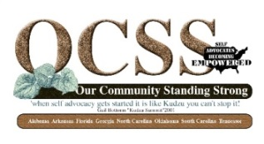**Regional Projects**

**Do we consider a Regional Project?**

**Tips for producing blogs and Vlogs**

**Vlogging/Blogging: Chaqueta and University of South Carolina**

**Money for state projects**

**How can we spend our money to support our state efforts?**

** Spring Meeting**

**Who would like to host our meeting?**

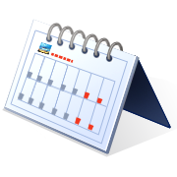**Dates to remember:**

**November 2014:**

**Signed State Contracts and Travel Assistance voucher due if not already submitted**

**December 2014:**

**State calls**

**December 30, 2014: $1250.00 Invoice and state plan quarterly report**

**January 2015:**

**January 14, 2015: Advisory Committee Meeting to share progress on state plans (Webinar)**

**February 2015:**

**February 11, 2015: Webinar-Topic to be announced**