**State Name**: South Carolina

**Organization Name: South Carolina Self-Advocacy Council (IMPACT SC)**

Demographic survey from Survey Monkey (insert your information)

**Top five things we need help** with in our state

Finding stable funding for self-advocacy,

Writing Grants,

Writing grant reports

Submitting invoices

Tracking grant Money

Creating a strategic plan/business plan for the organization to reach its future goals

Becoming incorporated and getting our 501 C 3 paperwork completed

**Mission statement**



|  |
| --- |
| Our mission statement is …  The mission is Individuals motivating people to achieve change together. |

**Our History**



We are a really young organization, that started in 2005 after a state conference was held in 2004 and self-advocates expressed a need to be more empowered with letting their voices be heard. It also provides a way for people with intellectual disabilities to network with other states in order to build a solid self-advocacy foundation and gain trending information about the self-advocacy movement. The DD council, UCED (Center for Disability Resources), and DDSN helped us get started. Our state has two districts. We have over twenty self-advocacy groups statewide. We have 25 state members. Several council members serve on various boards and committees.

**(SCOTT Analysis)**

**Strengths:** Make a list of the things you are most proud of:



|  |
| --- |
| * Run meetings independently * Got rid of “R” word * State directory of self-advocacy groups * DD council and UCED (Center for Disability Resources) are supportive * Invited speaker to our monthly meeting so we speak to them about key issues mainly housing * Members have participated in SALT trainings and CLA training with in the state * Member produced vlog for “Elephant in the room” manual being created as a result of that vlog to be used as an educational tool for parent statewide * SC advisory council will have a website by the end of July * P&A produced voter education videos to educate people with disabilities about voting |



**Challenges:** Make a list of your challenges and barriers:

|  |
| --- |
| * Getting transportation to meetings/group events-getting better with this challenge Ebony Deloach will be able to attend COCA Meeting that is face-to face in Columbia SC July 21, 2016 * Lack of community awareness-getting better with this challenge Members are attend trainings and the council is being recognized for its work in the state |



**Opportunities:** Make a list of your resources: people, partnerships and money.

|  |
| --- |
| * Project vote participating state * OCSS grant (co-director and participant) * DD network (DD Council, P&A, UCED) * COCAS * Family connections * Partners in Policy Making (PIP) * Membership recruitment * Legislators * DDSN   Local groups working on:   * Build better relationships in the community * Transportation * Increasing technology * Working on better healthcare with medical professionals * Marriage penalty |

**Threats and Trends:** List the problems that you do not have control of and that keeps your group from accomplishing your goals:



|  |
| --- |
| * Lack of transportation * No consistent provider support (staff, lack of priority) * Limited funding * Provider’s control |

**State Technical Assistance Project Work Plan**



**Goal: Develop and Implement a State Technical Assistance Needs and Plan to strengthen the organization**

Measurable Outcome(s): Participating State Self Advocacy Organizations develop, implement and monitor an individualized plan for strengthening their organizations and local group’s capacity to run their organizations through partnerships with SABE, DD Network, and community organizations.

**State Name: South Carolina**

| **Objective** | **Action Steps** | **1\***  **October-December** | **2\***  **January-March** | **3\***  **April-June** | **4\***  **July-September** |
| --- | --- | --- | --- | --- | --- |
| **To Develop or Enhance partnerships with DD Partners in your state** | 1. **Spoke to Mr. Horton about establishing website** 2. **SC state SALT training** 3. **Working on state plan for our state advisory council** 4. **Person Centered Planning group will begin train for its members in July** |  |  | ✓ | ✓  ✓  ✓ |
| **Increase connections to the grassroots to promote self advocacy efforts** | 1. **Host 2 per quarter (8 for year) Grassroots Events with a partner to promote one or more of the issues identified in the needs assessment: Employment First/voting rights/human rights/self advocacy membership recruitment of Individuals with Disabilities, Olmstead, Marriage Penalty, Community Living, Transportation, Affordable Housing, relationships**   **-Kelley Eifert/Cassidy Evans spoke to group separately about person centered planning February/April** |  |  |  |  |
| **Enhance the state leaderships skills in providing peer to peer technical assistance in their state and the region** | 1. **Participate in Quarterly Advisory Committee meetings for OCSS Completed** 2. **Attend Face to Face Meetings of the Webinar completed** 3. **Present on at least one OCSS Webinar** 4. **Submit at least 2 blogs or Vlogs on issues of concern (completed)-Elephant in the room various members Being self-advocate?** 5. **Participate in OCSS Webinar Completed** |  |  |  |  |
| **Establishment of state structure to maintain connections with grassroots** | 1. **Develop a strategic plan and funding (financial plan) for a state structure that supports grassroots issues in process will begin discussion Mid July** 2. **Secure at least one grant per year**   **with the support of your partners**  **(Working with Elephant in the Room**  **with the ARC)**   1. **Complete 501(C)3 application** |  |  |  |  |

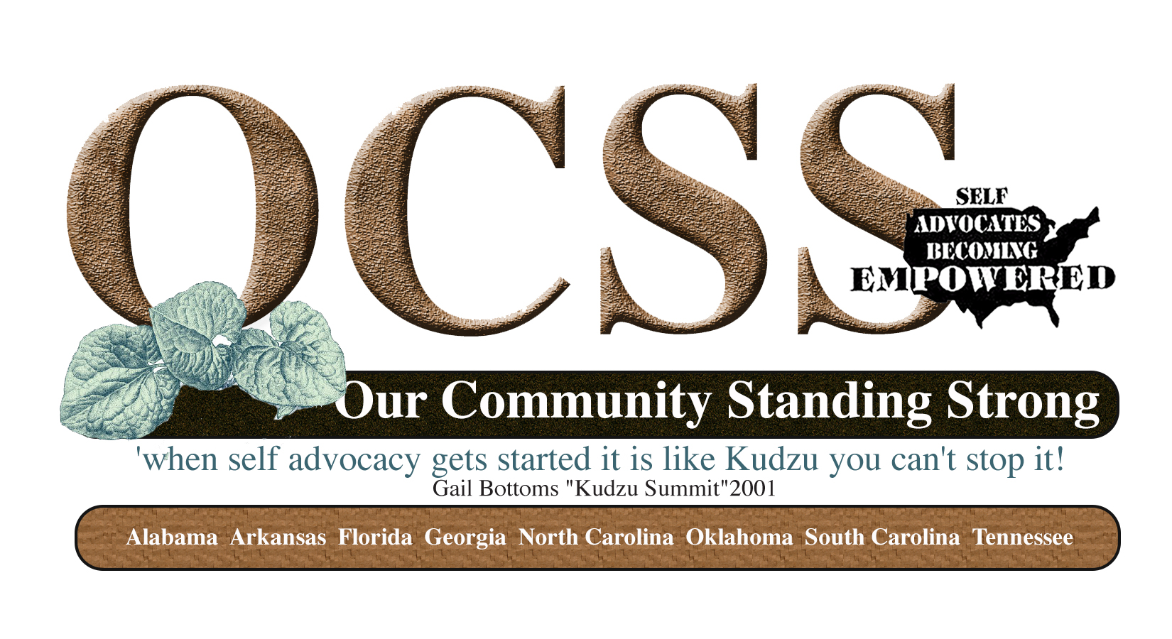

**Minutes**

**State Call South Carolina**

**12/11/14**

**11:30 AM CST-12:30 PM EST**

**Participating: Impact South Carolina Board, Chaqueta Stuckey, Glenda Hyman Singletary, Juliana Huereña and Vicki Hicks Turnage**

* **Review of Work Plan to assure inclusion of contract requirements**



* **Identification of two ways SABE and OCSS can support your plan activities**
* **Surveys- Evaluation and 2015 Plans**
* **Questions and Answers**

**State Technical Assistance Project Work Plan**

**Goal: Develop and Implement a State Technical Assistance Needs and Plan to strengthen the organization**

Measurable Outcome(s): Participating State Self Advocacy Organizations develop, implement and monitor an individualized plan for strengthening their organizations and local groups’ capacity to run their organizations through partnerships with SABE, DD Network, and community organizations.

**State Name: South Carolina**

**Contractual requirements in red: South Carolina has addressed all of the required contractual areas:**

| **Objective** | **Action Steps** | **1\***  **October-December** | **2\***  **January-March** | **3\***  **April-June** | **4\***  **July-September** |
| --- | --- | --- | --- | --- | --- |
| **To Develop or Enhance partnerships with DD Partners in your state** | 1. **Host a retreat to identify ways and timeframes on activities that you can work together on** 2. **American Red Cross Volunteer Presentation** 3. **Establish state conference** 4. **Chat and Chew to discuss issues** |  |  |  |  |
| **Increase connections to the grassroots to promote self advocacy efforts** | 1. **Host 2 per quarter (8 for year) Grassroots Events with a partner to promote one or more of the issues identified in the needs assessment: Employment First/voting rights/human rights/self advocacy membership recruitment of Individuals with Disabilities, Olmstead, Marriage Penalty, Community Living, Transportation, Affordable Housing, relationships (what will be your issue(s)?)**   **What do you want to work on?**  **Transportation**  **Employment**  **Supportive Living**  **Relationships** |  |  |  |  |
| **Enhance the state leaderships skills in providing peer to peer technical assistance in their state and the region** | 1. **Participate in Quarterly Advisory Committee meetings for OCSS** 2. **Attend Face to Face Meetings of the Webinar** 3. **Present on at least one OCSS Webinar (what topic would you like to present)**   **Recruit Self advocates**  **Speak up for yourself**  **How to find transportation in your area**  **Beyond transportation**   1. **Submit at least 2 blogs or Vlogs on issues of concern (what will be your topic?)**   **Transportation**  **Training and education, how to**  **How to educate**   1. **Participate in OCSS Webinar** |  |  |  |  |
| **Establishment of state structure to maintain connections with grassroots** | 1. **Develop a strategic plan and funding (financial plan) for a state structure that supports grassroots issues** 2. **Secure at least one grant per year with the support of your partners (what will be the purpose of your grant?)**   **The ARC**  **What will be the outcomes?**  **Health wellness and community participation**  **Where? 3 counties: Florence County (Walk this Way),**  **How many people?**  **By when?**   1. **Complete 501(C)3 application** |  |  |  |  |

**How can the OCSS Team or others on the Advisory Committee HELP you??? Identify two ways.**



1.) Training

2.) Meeting conference with other states within the region

3.) Help with specific issues such as: employment (work with groups of people)

4.) Learn how to talk to people without getting mad at them, anger management

**Questions and Answers:**



Please remember to complete the following surveys:

Evaluation of year 1

2015 activities year 2

**Impact South Carolina Process report**

* In Our Own Words: Why We Want Parents to Talk to us About Sex 1ST vlog featuring various member of the SC advisory council
* 1st meeting of February 25th 2016—Election year
* Disability Advocacy Day March 2, 2016
* Human Services providers conference (Impact exhibit)
* Self-Advocacy Leadership Training
* COCOA, P&A and Person-Centered work group meeting

**Webinars members were informed of or participated in**

1/12/16. Best Practices: Addressing Workplace Harassment – Employer’s Responsibilities Sponsored by Job Accommodation Network-Webinars posted on Website through August 2016

1/13/16 Workplace Bullying, Harassment, and Disability Sponsored by ADA Northeast center Webinars posted on their website

1/21/2016 advocating for your needs Sponsored by Able SC Webinars for 2016 posted on their website

1/26/16 Emergency Preparedness for Individuals with Disabilities Sponsored by DD council and other partners

1/27/16: Ticket to Work: Debunking the Three Biggest Myths about Disability Benefits and Work-Sponsored by Work Incentive Seminar Event (fourth Wednesday every month)

Peer-Support Empower hour monthly meeting posted on Able SC website

**Period: October 1, 2015-December 31, 2015**

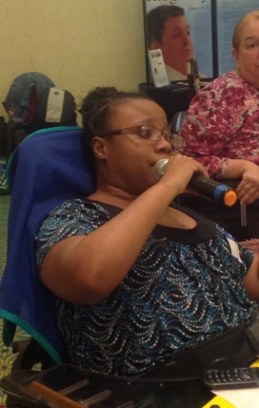

South Carolina Advisory Council had the meeting October 29, 2015

-We selected to members to attend the Human Services Providers Conference which will be March 2016

-Ebony Deloach announced that she is now a member of COCA

-Still working with P&A to produce voter’s education videos

Some member attended webinar about the Able ACT

-Ebony Deloach and Chaqueta Stuckey attended the OCSS Face-to-Face meeting in Atlanta.

An outline was created by Ebony Deloach to discuss OCSS and our commitment to the grant and shared with members

A representative for Columbia will meet with 2 members of IMPACT to interview them about as a part of the service plan survey. December 7st and December 9th

Impact welcomed a new member

IMPACT getting prepared for Disability Advocacy Day

Able South Carolina had an Empower hour some members attended.

Amanda Pollack from the ARC of South Carolina spoke the members of IMPACT and some recorded videos about relationships (possible vlogs)

November 19th Webinar Ebony Deloach attended

Able SC will host a webinar: Networking for Social Opportunity December 15th members were informed about the webinar 2-3 pm

Members of IMPACT will have an opportunity to take part in Brain Injury Association Survey BIASC December 8, 2015 identifying transportation barriers (survey distributed at IMPACT meeting)

**Local self-advocacy events (Voices for PRIDE)**

* Voices for PRIDE Executive Committee attended SCDDSN Commission Meeting on August 20
* Held a fundraiser on Sept 3
* Held a contest for self-advocates submitting a design for the agency Christmas card during the month of Sept.
* Held an assembly program for the day program on RESPECT
* Held a fundraiser on Oct 27
* Voices for PRIDE Executive Committee attended the Newberry DSN Board of Directors Meeting on Nov. 10

**Upcoming Event**

Dec 14 – Voices for PRIDE will host a “thank you” luncheon for people supported and staff.  This is done annually to thank people for their support of the fundraising that VFP does throughout the year.

Ebony Deloach volunteers as an American Red Cross Volunteer and assisted with the SC floods. She is now the casework supervisor and she manages cases for 6 counties in South Carolina. She also volunteers with Services to the Armed forces as a caseworker. She also volunteers for Hope Haven of the Low country as the scheduling coordinator.

**Our next advisory meeting is December 10th**