IMPACT South Carolina
Period: October 1, 2015-December 31, 2015

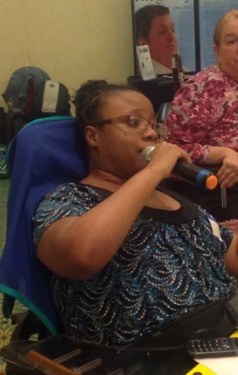
South Carolina Advisory Council had the meeting October 29, 2015
-We selected to members to attend the Human Services Providers Conference which will be March 2016
-Ebony Deloach announced that she is now a member of COCA
-Still working with P&A to produce voter’s education videos
Some member attended webinar about the Able ACT
-Ebony Deloach and Chaqueta Stuckey attended the OCSS Face-to-Face meeting in Atlanta.
An outline was created by Ebony Deloach to discuss OCSS and our commitment to the grant and shared with members
A representative for Columbia will meet with 2 members of IMPACT to interview them about as a part of the service plan survey. December 7st and December 9th
Impact welcomed a new member
IMPACT getting prepared for Disability Advocacy Day
Able South Carolina had an Empower hour some members attended.
Amanda Pollack from the ARC of South Carolina spoke the members of IMPACT and some recorded videos about relationships (possible vlogs)
November 19th Webinar Ebony Deloach attended
Able SC will host a webinar: Networking for Social Opportunity December 15th members were informed about the webinar 2-3 pm
Members of IMPACT will have an opportunity to take part in Brain Injury Association Survey BIASC December 8, 2015 identifying transportation barriers (survey distributed at IMPACT meeting)

Local self-advocacy events (Voices for PRIDE)
-Voices for PRIDE Executive Committee attended SCDDSN Commission Meeting on August 20
-Held a fundraiser on Sept 3
-Held a contest for self-advocates to submit a design for the agency Christmas card during the month of Sept.
-Held an assembly program for the day program on RESPECT
-Held a fundraiser on Oct 27
-Voices for PRIDE Executive Committee attended the Newberry DSN Board of Directors Meeting on Nov. 10

Upcoming Event
Dec 14 – Voices for PRIDE will host a “thank you” luncheon for people supported and staff. This is done annually to thank people for their support of the fundraising that VFP does throughout the year.

Ebony Deloach volunteers as an American Red Cross Volunteer and assisted with the SC floods. She is now the casework supervisor and she manages cases for 6 counties in South Carolina. She also volunteers with Services to the Armed forces as a caseworker. She also volunteers for Hope Haven of the Low country as the scheduling coordinator.

Our next advisory meeting is December 10th

